Agentic AI Framework for Context-Aware Semantic Understanding and Intelligent Assistance of Dynamic Web Forms
Submitted in Partial Fulfilment of the Requirement
for the Award of the Degree of Bachelor of Technology in
Computer Science
Submitted To

SVKM’s NMIMS
Mukesh Patel School of Technology Management & Engineering
Shirpur Campus Maharashtra
Submitted By
Ashmit Patil | 70552300048
Sanket Mali | 70552300067
Pinak Salunke | 70552300049
Under the Supervision of
Dr. Nitin S. Choubey
Head of Department, Dept. of Computer Science
DEPARTMENT OF COMPUTER SCIENCE
Mukesh Patel School of Technology Management & Engineering
ACADEMIC SESSION 2026–27

CERTIFICATE
This is to certify that the project entitled Agentic AI Framework for Context-Aware Semantic Understanding and Intelligent Assistance of Dynamic Web Forms has been done by:
Ashmit Patil - 70552300048 (Roll No. 246)
Sanket Mali - 70552300067 (Roll No. 265)
Pinak Salunke - 70552300049 (Roll No. 247)
under my guidance and supervision and has been submitted in partial fulfilment of the degree of Bachelor of Technology in Computer Science of SVKM’s NMIMS (Deemed-to-be University), MPSTME Shirpur Campus (M.H.), India.

____________  Dr. Nitin S. Choubey  Project Mentor  (Internal Guide) | ____________  Examiner
Date:
Place: Shirpur
____________
Dr. Nitin S. Choubey
Head of the Department
DEPARTMENT OF COMPUTER SCIENCE
Mukesh Patel School of Technology Management & Engineering
DECLARATION
We hereby declare that the project entitled Agentic AI Framework for Context-Aware Semantic Understanding and Intelligent Assistance of Dynamic Web Forms submitted in partial fulfilment of the degree of Bachelor of Technology in Computer Science of Mukesh Patel School of Technology Management & Engineering Shirpur, SVKM’s Narsee Monjee Institute of Management Studies (NMIMS) Deemed-to-be University (M.H.), India, is a record of original work carried out by us under the guidance and supervision of Dr. Nitin S. Choubey, Head of Department, Department of Computer Science.
The matter embodied in this report has not been submitted, in part or fully, for the award of any other degree or diploma from this or any other university or institution. Wherever the work of others has been used, it has been duly acknowledged and cited.
Ashmit Patil | 70552300048 | ________________________
Sanket Mali | 70552300067 | ________________________
Pinak Salunke | 70552300049 | ________________________
Date:
Place: Shirpur
DEPARTMENT OF COMPUTER SCIENCE
Mukesh Patel School of Technology Management & Engineering
ACKNOWLEDGEMENT
On completing this capstone project, we would like to thank everyone who helped us reach our goal. Above all, we are grateful to the Almighty for giving us this opportunity and guiding us throughout the project.
We are deeply grateful to Dr. Nitin S. Choubey, Head of the Department of Computer Science, MPSTME, Shirpur, for their invaluable guidance, constant encouragement and support throughout the project. Their expertise and suggestions helped us put our theoretical knowledge into practice. As Head of the Department, they also provided the infrastructure and resources we needed.
We also extend our gratitude to Dr. Venkatadri Marriboyina, Associate Dean of MPSTME, Shirpur Campus, and Dr. Sunita Patil, Director of SVKM’s NMIMS, Shirpur Campus, for providing us with the necessary facilities, encouragement and a supportive learning environment.
We are thankful to the faculty members and staff of the Computer Science Department for the technical knowledge and support they gave us throughout our B.Tech. studies, and to the reviewers whose comments improved this report. We also thank our friends for their encouragement and their direct and indirect contributions to this project.
Finally, we sincerely thank everyone whose guidance, effort and support made the completion of this project possible.

Ashmit Patil
Sanket Mali
Pinak Salunke
ABSTRACT
Online forms for admissions, scholarships, examinations, banking and government services repeatedly ask for personal details that already exist in documents the applicant holds. Conventional browser autofill can only reuse values that the user has previously typed into other forms. It cannot read documents, cannot show where a value came from and does not detect disagreements between sources. This work addresses the problem of filling dynamic web forms from a user’s own documents while keeping every value traceable and every decision under the user’s control.
The report presents the Smart Form Auto-Filling System, a privacy-first agentic framework that combines document understanding, a shared ontology of personal-data concepts and retrieval-augmented generation. Uploaded documents, including scanned images, are read with optical character recognition, classified by document type and converted into structured facts, each linked to its source document, page and evidence text. Disagreements between documents are presented to the user as conflicts instead of being resolved silently. For an unseen web form, a graph-based pipeline matches each field to an ontology concept, applying deterministic rules first and a language model only to ambiguous fields, proposes a value grounded in stored evidence and decides whether the value is ready or requires review. A browser extension fills only the values that the user approves, verifies them on the page and never submits the form.
The system was evaluated with automated tests and with a synthetic set of documents and forms. The results indicate that it extracts document values with high accuracy and fills forms with few errors, while holding uncertain or sensitive values for the user’s review. The work shows that evidence-grounded, user-approved form filling is a practical alternative both to conventional autofill and to autonomous web agents.
Keywords: form autofill, document information extraction, optical character recognition, retrieval-augmented generation, LangGraph, MongoDB, Chrome extension, privacy.
TABLE OF CONTENTS
Sr. No. |  | Chapter No. | Page
 |  | Certificate | i
 |  | Declaration | ii
 |  | Acknowledgement | iii
 |  | Abstract | iv
 |  | List of Figures | vii
 |  | List of Tables | viii
 |  | List of Abbreviations | ix
 | 1 | INTRODUCTION | 1
 | 1.1 | Background of the Project Topic | 1
 | 1.2 | Motivation and Scope of the Project | 2
 | 1.3 | Problem Statement | 2
 | 1.4 | Aim and Objectives | 3
 | 1.5 | Salient Contributions | 3
 | 1.6 | Organisation of the Report | 4
 | 2 | LITERATURE SURVEY | 5
 | 2.1 | Introduction to the Overall Topic | 5
 | 2.1.1 | Basic Concepts Used in This Project | 5
 | 2.2 | Exhaustive Literature Survey | 6
 | 2.2.1 | Web Agents and Benchmarks | 6
 | 2.2.2 | Agents, Knowledge and Memory | 7
 | 2.2.3 | Form Understanding, Form Filling and Form Security | 7
 | 2.2.4 | Supporting Techniques and Security | 8
 | 2.3 | Comparative Analysis | 9
 | 2.4 | Research Gap | 10
 | 3 | PROBLEM DEFINITION & PROPOSED SOLUTION | 11
 | 3.1 | Problem Definition | 11
 | 3.2 | Existing System and Its Limitations | 11
 | 3.3 | Proposed Solution | 12
 | 3.3.1 | Workflow Summary | 12
 | 3.3.2 | Advantages of the Proposed Solution | 13
 | 3.4 | Requirements | 13
 | 3.5 | Technology Stack and Justification | 14
 | 3.6 | Assumptions and Constraints | 15
 | 4 | DESIGN | 16
 | 4.1 | System Architecture | 16
 | 4.2 | Data Flow | 19
 | 4.3 | Database Design | 19
 | 4.4 | Form-Filling Pipeline | 21
 | 4.5 | Decision Rules | 22
 | 4.6 | Security Design | 23
 | 5 | RESULT ANALYSIS: SNAPSHOTS | 24
 | 5.1 | Dashboard and Document Processing | 24
 | 5.2 | Profile and Conflicts | 26
 | 5.3 | Ask Documents | 28
 | 5.4 | Browser Extension | 29
 | 5.5 | Measured Results | 30
 | 5.6 | Analysis | 32
 | 6 | TESTING | 33
 | 6.1 | Testing Strategy | 33
 | 6.2 | Test Environment | 33
 | 6.3 | Test Inventory | 34
 | 6.4 | Test Cases | 34
 | 6.5 | Test Results | 35
 | 6.6 | Discussion | 36
 | 6.7 | Achievement of Objectives | 36
 | 6.8 | Principal Findings | 36
 | 7 | CONCLUSION & FUTURE WORK | 38
 | 7.1 | Conclusion | 38
 | 7.2 | Limitations and Future Work | 39
 |  | References | 40
 |  | Appendix A: Source Code Excerpts | 44
 |  | Appendix B: Dataset and System Data Sheets | 46
 |  | Appendix C: List of Components | 49
 |  | Appendix D: List of Papers Presented and Published | 50
 |  | Appendix E: Prints & Plagiarism Report | 51
LIST OF FIGURES
Figure No. | Title | Page
3.1 | Two-phase workflow: building the profile (Phase A) and filling a form (Phase B) | 13
4.1 | End-to-end architecture and data flow, from document upload to reviewed form filling | 17
4.2 | Data-flow diagram, level 1 | 19
4.3 | Entity–relationship diagram of the MongoDB collections and the ChromaDB chunk index | 20
4.4 | Flowchart of the decide step of the form-filling pipeline | 22
5.1 | Dashboard overview of the demonstration account | 24
5.2 | Facts extracted from the Class 12 mark sheet, with evidence | 25
5.3 | Profile page with the supporting documents of each value | 26
5.4 | Conflict between two dates found in one certificate | 27
5.5 | Ask Documents: answer with the cited source | 28
5.6 | Extension popup: review before filling (left) and verified result (right) | 29
5.7 | Filled subject-wise marks on the synthetic Class 12 form | 30
LIST OF TABLES
Table No. | Title | Page
1.1 | Application domains of the system | 2
2.1 | Summary of the surveyed literature | 9
2.2 | Comparison of existing approaches with the proposed system | 9
3.1 | Existing practice compared with the proposed system | 12
3.2 | Functional requirements | 14
3.3 | Technology stack and justification | 15
5.1 | Extraction, retrieval and question-answering results (15 synthetic documents) | 31
5.2 | Browser autofill results on 15 synthetic forms | 31
6.1 | Automated test inventory | 34
6.2 | Representative test cases | 35
6.3 | Test results: total, passed and failed test cases | 35
6.4 | Achievement of the objectives | 36
7.1 | Limitations and proposed future work | 39
B.1 | Data sheet of the demonstration dataset | 46
B.2 | Synthetic documents of the demonstration dataset | 46
B.3 | Synthetic forms of the demonstration dataset | 47
B.4 | Commands that run the automated test suites | 48
B.5 | Main API endpoints used in the workflow | 48
C.1 | Software components and versions | 49
C.2 | Development and test computer | 49
LIST OF ABBREVIATIONS
Abbreviation | Full form
AI | Artificial Intelligence
API | Application Programming Interface
CAPTCHA | Test that tells computers and humans apart
CPU | Central Processing Unit
DB | Differentiable Binarization (text detector)
DOCX | Microsoft Word document format
FR | Functional Requirement
GUI | Graphical User Interface
HTML | HyperText Markup Language
HTTP | Hypertext Transfer Protocol
ICLR / ICML | Int. Conf. on Learning Representations / on Machine Learning
IFSC | Indian Financial System Code
JPG | JPEG image file format
JSON | JavaScript Object Notation
KYC | Know Your Customer
LLM | Large Language Model
OCR | Optical Character Recognition
ONNX | Open Neural Network Exchange
OTP | One-Time Password
PAN | Permanent Account Number
PDF | Portable Document Format
PIN | Postal Index Number
PNG | Portable Network Graphics image file format
RAG | Retrieval-Augmented Generation
REST | Representational State Transfer
TC | Test Case
TXT | Plain-text file format
UI | User Interface

Chapter 1
INTRODUCTION
This chapter introduces the Smart Form Auto-Filling System and explains why filling web forms from personal documents is worth automating. It then states the scope, problem, aim and objectives of the project, lists its main contributions and outlines how the report is organised.

1.1 Background of the Project Topic
Almost every service that students and working adults use today starts with an online form. Admission and scholarship portals ask for marks, board names and addresses. Examination portals ask again for the same name, date of birth and category details, and banks ask for identity numbers and income. Most of these facts are already printed in documents the person holds, such as an Aadhaar or PAN card, Class 10 and Class 12 mark sheets, a birth certificate, an income or domicile certificate, or a bank passbook.
Web browsers reduce part of this effort with autofill, which remembers values typed earlier and offers them again when a field looks similar. This works well for an e-mail or postal address, but autofill has three limits. It can only repeat values the user has typed before, so it cannot use the facts printed in documents. It matches fields mainly by their technical names, so a label such as “Year of passing (Class XII)” or “Father’s name” is easily confused with a similar field. It also keeps no record of where a value came from. In addition, Lin, Ilia and Polakis showed that web pages can hide fields that browser autofill then fills silently (Section 2.2.3).
Recent progress in artificial intelligence (AI) makes a better approach possible. A large language model (LLM) is an AI model trained on very large amounts of text that can read an unstructured document and return structured information. Retrieval-augmented generation (RAG) lets such a model answer from passages of the user’s own documents rather than from general knowledge (Section 2.1.1). Research on web agents (Section 2.2.1) shows that models can operate real web pages, but these agents act on their own. Form filling with personal data calls for a different design, namely an assistant that proposes values from verified documents, explains each proposal and leaves every decision to the user. This project builds such an assistant.

1.2 Motivation and Scope of the Project
Typing the same details again and again is slow and error-prone. A wrong digit in an identity number, a date in the wrong format or marks copied from the wrong examination can lead to a rejected application. When two documents give different values, such as two spellings of a name, a simple autofill tool picks one without telling the user. The project therefore pursues three goals together, namely less typing, values that can be traced to evidence and a user who stays in control. Table 1.1 lists the kinds of portal on which the same facts recur.
Table 1.1 Application domains of the system
Domain | Typical form | Facts that recur
Education | Admission, scholarship and examination applications | Name, date of birth, board, seat number, subject marks, percentage
Government services | Certificates, voter and passport services | Name, parents’ names, address, identity numbers, category
Banking | Account opening and KYC (know-your-customer) update | Identity numbers, address, income, account details
Employment | Recruitment portals | Education, experience, skills, contact details

In scope: upload and processing of PDF, Word (DOCX), plain-text and image files, optical character recognition (OCR) for scanned images, seventeen common Indian document types, a profile with sources and conflict resolution, a Chrome browser extension that reads the fields of any web form, suggests values and fills the approved ones, and a question-answering page over the user’s documents.
Out of scope: automatic submission of forms, filling of passwords, payment-card details, one-time passwords (OTPs) or CAPTCHAs, browsers other than Chrome, mobile applications, and text in Indian scripts, since the OCR models used read English text only.

1.3 Problem Statement
Existing autofill tools cannot build a profile from a person’s documents or show evidence for the values they insert. They handle disagreeing sources poorly, and some designs even fill hidden or sensitive fields. This project addresses the problem of designing and implementing a system that (a) extracts structured facts with evidence from personal documents, (b) matches the fields of any web form to those facts by meaning rather than by exact field names, (c) detects and shows disagreements between documents, and (d) fills values only after the user approves them, without reading what the page already contains, touching sensitive fields or submitting the form.

1.4 Aim and Objectives
The aim of the project is to build a privacy-first assistant that fills web forms from the user’s own documents, keeps every value traceable and leaves every decision to the user. The objectives are:
1. Document understanding with evidence: read PDF, Word, text and scanned image documents, recognise the type of document, and extract personal facts into a fixed vocabulary, recording for every fact its source document, page, evidence text and confidence.
2. A verified profile: combine the facts from all documents into one profile, detect when documents disagree, and let the user resolve each disagreement.
3. Semantic form filling: recognise what each field of an unseen web form asks for, propose a value from the profile or from cited document text, and fill only the values the user approves.
4. Grounded question answering: answer the user’s questions about their own documents and show the document and page behind every answer.
5. Safety and verification: protect personal data (no automatic submission, sensitive fields skipped, defences against manipulated text, per-user isolation) and verify the system with automated tests and a measured evaluation.

1.5 Salient Contributions
- One shared vocabulary: an ontology of 220 concepts in 32 domains, with 645 alternative phrasings (aliases), is used by extraction, field matching and filling, so that all parts of the system mean the same thing by “Class 12 percentage” or “father’s name”.
- Evidence for every value: each fact stores its document, page, the exact text it came from and a confidence score, and disagreements between documents become visible conflicts instead of silent choices.
- Rules before models: the fixed rules handle most of the cases. The language model is invoked only for fields that the rules cannot determine, and any value it predicts for a document must be a substring of its cited text.
- User-approved filling: the extension does not read pre-filled values, disables autofill on password fields, gives a reason and source on every suggestion, autofills only the user-selected fields, verifies that the page preserved the filled values, and never submits the form.
- Measured results: 453 automated tests and a review of 15 synthetic documents and 15 forms, illustrating what the system is capable of and areas for future development.

1.6 Organisation of the Report
Chapter 2 discusses the basic concepts of the project, surveys published research on web agents, document understanding, form filling and security, and presents the research gap. In chapter 3, problem specification is described, then the differences between the approach and the existing practice is discussed, and the requirements and technologies are outlined. Chapter 4 describes the design: architecture, data flow database form filling pipeline, the decision rules. Chapter 5 presents the snapshots of the working system, and discusses the measured results. Chapter 6 describes the testing and presents the test results, and evaluates the degree of success in the objectives. Chapter 7 gives the conclusion, future work, then the References and Appendices follow.

Chapter Summary
Online forms keep requesting facts that are already in a person's documents, but browser autofill cannot see those documents, evidence, or resolve conflicts. This project designed an assistant that pulls out evidence-based facts, aligns form fields semantically, and fills only what the user approves. This chapter describes its scope, the problem, five goals, and key contributions.

Chapter 2
LITERATURE SURVEY
This chapter first explains, in simple terms, the concepts on which the project is built. It then reviews published research by theme, compares the main approaches with the proposed system and identifies the gap that the project addresses.

2.1 Introduction to the Overall Topic
Automatic form filling from documents combines four research areas. Document understanding turns scanned or digital documents into structured facts. Retrieval-augmented generation grounds a language model’s answer in passages retrieved from the user’s documents. Web agents use language or vision-language models to act on web pages, and security research shows how autofill and LLM-based applications can be abused. Section 2.1.1 explains the basic concepts these areas rely on, and Section 2.2 reviews the published work in each area. References are numbered in the order in which they are first cited, and only peer-reviewed conference papers are cited, while software products are named in the text and listed with their versions in Appendix C.

2.1.1 Basic Concepts Used in This Project
Database and MongoDB. A database is an organised store of data that a program can save, search and update reliably. Traditional relational databases keep data in tables with fixed columns. MongoDB is a document database, which stores each record as a flexible document of field–value pairs, similar to JSON (JavaScript Object Notation), and groups similar documents into collections. Records of different shapes can therefore sit side by side, which suits facts as varied as a date of birth and a table of subject marks. In this project MongoDB stores user accounts, uploaded-document records, extracted facts with their evidence, and form-filling sessions.
Embeddings and vector databases. An embedding is a list of numbers that represents the meaning of a piece of text. Texts with similar meaning have nearby embeddings. Sentence-BERT [1] produces such sentence embeddings, which can be compared quickly by cosine similarity, and dense passage retrieval [2] showed that such learned embeddings find relevant passages for question answering better than keyword matching. A vector database stores these lists and quickly finds the ones closest to a query. The project uses ChromaDB to store embeddings of short passages (chunks) of each document, so that a question such as “What was my Class 12 percentage?” finds the right passage even if the words differ.
Large language models and RAG. An LLM predicts text and can therefore answer questions or turn text into structured data, but it can also invent facts. Lewis et al. [3] introduced retrieval-augmented generation (RAG), which reduces this risk by pairing the model with a searchable index of passages and asking it to answer from the passages it retrieves. Self-RAG [4] adds a self-check in which the model decides when to retrieve and critiques whether its output is supported by the retrieved passages. The project uses a stricter, rule-based check, in which a value proposed from a document must appear word for word in the passage the model cites.
Other building blocks. OCR converts an image of text into characters. Modern OCR first detects text regions, for example with the differentiable-binarization detector (DB) [5], and then recognises the characters in each region. The PP-OCR models used in the project follow this two-stage design and run on ordinary computers. An ontology is a controlled list of concepts together with their alternative names and data types, and a typical concept is personal.date_of_birth. A REST API (Representational State Transfer Application Programming Interface) lets the dashboard and the extension talk to the server over HTTP, and the project builds it with FastAPI. LangGraph runs a program as a graph of steps that share a state. A Chrome extension is an add-on installed into the browser; Manifest V3 is the latest extension platform with a permissions system. Prompt injection is text embedded in data to instruct an LLM. Greshake et al. [6] proved indirect prompt injection, where web pages or documents contain instructions that assume control of an LLM-driven program, and Liu et al. [7] provided a taxonomy for such injections and a benchmark with existing mitigation techniques, across several LLMs and tasks.

2.2 Exhaustive Literature Survey

2.2.1 Web Agents and Benchmarks
WebArena [8] offers a self-hosted environment featuring realistic websites and extended tasks, with evaluation indicating that LLM agents perform Really below human levels. Mind2Web [9] gathered over 2,000 tasks from 137 actual websites and introduced a two-stage approach: a small model first filters page elements, followed by a larger model selecting actions. SeeAct [10] examined GPT-4V as a web agent and identified groundingconnecting a textual plan to the correct page elementas the primary challenge. WebVoyager [11] developed a multimodal agent operating end-to-end on fifteen live websites. CogAgent [12] is an 18-billion-parameter vision-language model capable of reading high-resolution screenshots, while SeeClick [13] pre-trains models to identify interface elements from screenshots. Ferret-UI [14] adapts this method for mobile screens. WorkArena [15] evaluates agents on enterprise knowledge-work tasks, finding them promising but not yet dependable. LCoW [16] trains agents to simplify complex pages for improved decision-making. WebAgent [17] interacts with real websites by planning sub-instructions, summarizing lengthy HTML pages into task-relevant snippets, and generating programs to operate the page
Relevance and limits. Works for have demonstrated that models can be persuaded to act on a web page, and that locating the right element is quite difficult. We sidestep the grounding problem for form fields by reading the structure of the page directly. We give each field a stable identifier, and fill targets that identifier. An extension cannot do anything the user did not explicitly tell it to do.

2.2.2 Agents, Knowledge and Memory
Nguyen et al. [18] survey agents that operate graphical interfaces, covering their benchmarks, architectures and training methods. Generative agents [19] keep a memory stream of experiences, retrieve items by recency, importance and relevance, and reflect on them to plan. In these terms, the project’s profile is a persistent memory in which every item is linked to evidence. Think-on-Graph [20] lets an LLM explore a knowledge graph step by step, so that its answer follows explicit and traceable reasoning paths, and HippoRAG [21] combines a model, a knowledge graph and graph ranking to improve retrieval across several facts. The project’s ontology plays the role of a small explicit knowledge structure, while its questions are mostly direct look-ups for which single-step retrieval is sufficient.

2.2.3 Form Understanding, Form Filling and Form Security
LayoutLM [22] pre-trains a model on both the text and the two-dimensional layout of scanned documents and was shown to improve key-information extraction on form-understanding benchmarks. This is the reading side of the problem. On the filling side, Hartmann and Mühlhäuser [23] proposed context-aware form filling, which suggests values for web-form fields from information about the user’s current context, and Wang et al. [24] presented a framework that reuses values entered in one web application to fill forms in others. FormLM [25] helps designers create online forms by modelling their structure and text. FormNexus [26] infers the meaning and constraints of web-form fields from their text, structure and position, using an LLM, in order to generate tests. Lin et al. [27] show that browser autofill can be exploited through hidden fields and its preview feature in Chromium-based browsers.
Relevance and limits. These studies show that the meaning of a field can be inferred from its label and surroundings, which the project does with ontology aliases and nearby text. None of them builds a personal profile from documents or asks the user to review each value, and the autofill study directly motivates three rules of the project, namely that sensitive and hidden fields are skipped, existing values are never read, and nothing is filled before approval.

2.2.4 Supporting Techniques and Security
MiniLM [28] compresses large transformer models into smaller, faster encoders. The project's embedding model, all-MiniLM-L6-v2, is part of this family and operates with the Sentence-BERT method described in Section 2. 1. 1. The PP-OCR models from Section 2. 1. 1 are used in the project via RapidOCR, an open-source toolkit for ONNX Runtime that does not require a graphics processor. For security, the indirect injection attacks and the benchmark of attacks and defences discussed in Section 2. 1. 1 support the project's approach of treating every page and document as untrusted input. Table 2. 1 lists the surveyed papers in the order of their reference numbers.
Table 2.1 Summary of the surveyed literature
Ref. | Work (venue, year) | Main idea | Limitation for this project
[6] | Indirect injection (AISec 2023) | Attacks via retrieved content | Shows the risk, no assistant
[7] | Injection benchmark (USENIX Sec. 2024) | Formal attacks and defences | Shows the risk, no assistant
[8] | WebArena (ICLR 2024) | Realistic self-hosted web tasks | Task automation, no personal data or approval
[9] | Mind2Web (NeurIPS 2023) | 2,000+ tasks on 137 websites | Agent actions, not form values
[10] | SeeAct (ICML 2024) | GPT-4V web agent, grounding is hard | Autonomous, visual grounding
[11] | WebVoyager (ACL 2024) | Multimodal agent on live sites | Autonomous, no evidence trail
[12] | CogAgent (CVPR 2024) | Screenshot-based 18B model | Heavy model, screenshots only
[13] | SeeClick (ACL 2024) | GUI grounding pre-training | Locates elements, not meaning
[15] | WorkArena (ICML 2024) | Enterprise task benchmark | Benchmark, agents not reliable
[17] | WebAgent (ICLR 2024) | Plans and writes programs for real sites | Autonomous, no user approval
[21] | HippoRAG (NeurIPS 2024) | Graph-based memory retrieval | Multi-step retrieval not needed
[22] | LayoutLM (KDD 2020) | Text and layout pre-training | Reads forms but does not fill them
[23] | Context-aware filling (ICSC 2009) | Values from the user’s context | No documents, evidence or review
[24] | Cross-app autofill (SERVICES 2013) | Reuses values across web apps | Past entries, not documents
[25] | FormLM (EMNLP 2022) | Helps create online forms | Form design, not filling
[26] | FormNexus (ISSTA 2024) | LLM infers field constraints | Testing, not user assistance
[27] | Fill in the Blanks (CCS 2020) | Privacy threats of autofill | Analyses threats, no solution

2.3 Comparative Analysis
Table 2.2 compares the main families of approach on the properties that matter for this project, based on what the cited papers report.
Table 2.2 Comparison of existing approaches with the proposed system
Property | Browser autofill | Web agents [8], [10], [11] | Form research [23], [25], [26] | Proposed system
Reads the user’s documents | No | No | No | Yes, including scans
Keeps evidence for each value | No | No | No | Document, page, text
Handles disagreeing sources | No | No | No | Shows conflict, user decides
Matches fields by meaning | Partly | Yes (model) | Yes | Ontology rules, then LLM
User approves before action | Partly | Usually not | Not applicable | Always, per field
Skips sensitive or hidden fields | Known weakness [27] | Not reported | Not applicable | Yes, twice

2.4 Research Gap
Web agents act on pages but are designed for autonomy, not for reviewing personal data. Form-related research infers field meaning for form design, value prediction or testing, but not from a person's own documents. Document-understanding research reads documents but does not connect them to forms, and security research documents the risks without offering a safe assistant. Among the works reviewed, none combines a document-derived profile with evidence, conflict handling between documents, field matching by meaning, protection against prompt injection and mandatory user review in one deployable system. This project addresses that combination.

Chapter Summary
The principles on which the project was based were commented on. (for instance: databases MongoDB, embeddings, RAG, and OCR). The review consisted of 28 peer-reviewed conference papers. It was demonstrated that models can understand and interact with webpages, that grounding is hard, that autofill has privacy risks, and that retrieval improves factual answers. It did not reveal any work that is conflict-aware, user-approved, and uses personal documents to fill forms with evidence-based information; this summarizes the problem in Chapter 3.

Chapter 3
PROBLEM DEFINITION & PROPOSED SOLUTION
This chapter turns the gap identified in Chapter 2 into a precise problem, compares current practice with the proposed solution, describes its workflow and lists the requirements together with the technologies chosen to meet them.

3.1 Problem Definition
A user uploads a set of personal documents, from which the system must derive a set of facts. Each fact records a concept from the ontology (for example Class 12 percentage), its value, the source document and page, the evidence text and a confidence score. Later, for any web form the user opens, the system must produce a recommendation for each field, consisting of a status (ready, needs review, missing or blocked), an optional value, a reason and a source. A solution is acceptable only if it meets the following constraints:
1. Evidence: a value can be suggested only if it exists in a fact stored in memory, or the value is contained as verbatim in a document sentence in the window, which the system can recall.
2. Conflict transparency: in case of multiple values for a single valued concept, no fields are automatically filled in, and the candidates appear.
3. Sensitivity: No passwords, no payment details, OTPs, and CAPTCHAs, and the identity or the money value must be always verified.
4. Consent: only after the user responds to each field does the page change, and the form isn't ever submitted.
5. Isolation and untrusted input: no user has access to another user's data, and anything you copy from a web page or a document is "just data" and never commands.

3.2 Existing System and Its Limitations
Today a person types every value by hand, copies values from documents, or relies on browser autofill. Table 3.1 compares this practice with the proposed system on the points that matter for the problem definition.
Table 3.1 Existing practice compared with the proposed system
Aspect | Existing practice (manual typing or browser autofill) | Proposed system
Source of values | Typed by the user or remembered from earlier forms | Original facts taken from the files of the user
Matching fields | Technical field names and simple rules | Ontology synonyms and close text then an LLM for mystery fields
Evidence | None | Document page evidence text and confidence
Disagreeing values | One value chosen without notice | Conflict shown and the user selects
Sensitive and hidden fields | May be filled silently [27] | Skipped by the extension and then blocked again by the server
After filling | No check | Every value parsed from the page is output
Submission | By the user or the page | Never by the system

3.3 Proposed Solution
The solution works in two phases, shown in Figure 3.1. Phase A (steps 1 to 5) runs once for each uploaded document and builds the user’s profile. Phase B (steps 6 to 10) runs every time the user opens a web form and turns the profile into reviewed, filled values. Both phases share one knowledge store.

3.3.1 Workflow Summary
Phase A: build the user profile. (1) The user uploads a PDF, DOCX, TXT or image file. (2) The text is extracted, and scanned images and image-only PDF pages are read by OCR (RapidOCR with PP-OCR models). (3) The type of document is identified, for example a PAN card, a passport or a Class 12 mark sheet. (4) Facts are extracted by rules, with an optional LLM call for structured information. (5) The facts are merged with those already stored and kept, with their evidence, as the user’s profile. Because this processing can take several seconds, it runs in the background while the dashboard shows its progress.
Knowledge storage. Phase A stores the structured facts in MongoDB and the document text, split into chunks, in ChromaDB for semantic search. Phase B retrieves from both.
Phase B: fill a form. When the user opens a web form, (6) the extension scans the form’s fields and sends their description, but never their current values, to the server. (7) The server classifies each field, for example as a name, a date of birth or an address, using rules first and an LLM only for unclear fields. (8) It finds the best value in the profile and, if needed, in the document text through semantic retrieval (RAG), and decides whether the value is ready or needs review. (9) The user reviews the suggestions in the extension popup and approves each field. (10) The extension fills only the approved fields and reads each value back to verify that the page kept it. The form is never submitted by the system. The user presses the form’s own Submit button.
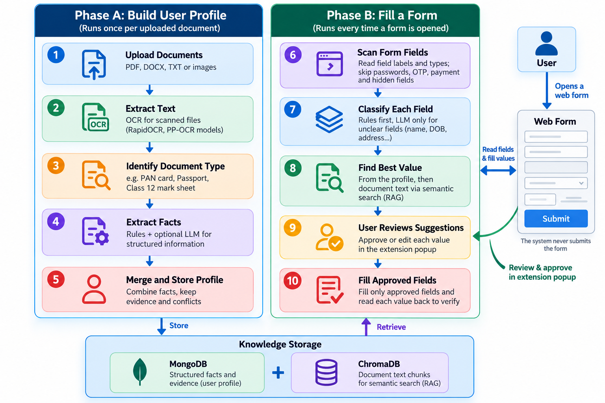
Figure 3.1 Two-phase workflow: building the profile (Phase A) and filling a form (Phase B)

3.3.2 Advantages of the Proposed Solution
- Traceable: every suggestion states where it came from and how certain the system is.
- Fewer errors: values are formatted to what each field expects, such as a date pattern or one option of a drop-down list.
- Safe by design: sensitive and hidden fields are skipped in two places, and the form is never submitted by the system.
- Low cost: the LLM is called only when the rules cannot decide, and the system keeps working, with fewer features, even without an LLM.

3.4 Requirements
Table 3.2 lists the functional requirements and the part of the system that implements each.
Table 3.2 Functional requirements
ID | Functional requirement | Implemented in
FR1 | Register, sign in, sign out and delete the account | Authentication service
FR2 | Upload PDF, DOCX, TXT, PNG or JPG files with type, size and duplicate checks | Providing document service
FR3 | Process documents in the background and show stage and progress | Celery worker and pipeline
FR4 | Read text, using OCR for scanned images | OCR (RapidOCR) text extractor
FR5 | Identify the document type (17 Indian types) | Register document
FR6 | Extract facts with source, page, evidence and confidence | Rule-based and LLM extractors
FR7 | View, add, edit and confirm profile values, and resolve conflicts | Fact service and dashboard
FR8 | Answer questions about the documents with cited sources | Ask Documents service
FR9 | Detect form fields, skipping sensitive and hidden ones | Extension content script
FR10 | Map fields to concepts and recommend values with reasons | Form-fill LangGraph pipeline
FR11 | Record the user’s decisions, fill approved values and verify them | Extension popup and content script
FR12 | Delete all data, with or without the account, and report service health | User-data and health services

The main non-functional requirements are security (hashed passwords, short-lived tokens, per-user isolation), privacy (the extension reads field descriptions, never field values), reliability (failures are reported, never hidden behind invented values), responsiveness (form analysis responds immediately and the popup checks progress every second), maintainability (automated tests and a continuous-integration workflow) and portability (the whole system starts with one Docker Compose command).

3.5 Technology Stack and Justification
Table 3.3 lists the technology used in each layer and the reason for choosing it. MongoDB, defined in Section 2.1.1, was chosen because each fact has a different shape and every query is made for one user. Software products are not cited, and their versions are listed in Appendix C.
Table 3.3 Technology stack and justification
Layer | Technology | Reason for the choice
Server (API) | Python 3.11, FastAPI, Pydantic | Fast asynchronous web framework with typed, validated requests
Fact store | MongoDB 8 | Flexible documents and efficient per-user queries
Search index | ChromaDB with all-MiniLM-L6-v2 [1], [28] | Self hosting your vector search and a tiny embedding model that runs on your CPU
OCR | RapidOCR on ONNX Runtime (PP-OCR models, DB text detection [5]) | Explicit graph of steps with conditions
Form pipeline | LangGraph | Explicit graph of steps with conditions
Language model | Google Gemini, with an optional local model through Ollama | Best measured accuracy, and the local fallback continues working offline.
Background jobs | Celery with Redis | Long processing does not block the user
Security | bcrypt [29], JSON Web Tokens | Salted password hashing and short-lived signed tokens
Dashboard | React 19, TypeScript, Vite | Component-based, type-checked user interface
Extension | Chrome Manifest V3, React 18 | Current extension platform with on-demand page access
Deployment | Docker Compose, Nginx | One command starts every service
Testing | pytest, Vitest, Playwright | Unit, integration and real-browser tests

3.6 Assumptions and Constraints
- Documents are in English (Indian bilingual documents are read from their English half), but handwriting and Indian scripts are not read.
- A configured LLM improves classification of unusual fields and the wording of answers. Without one, rule-based extraction, matching and filling still work.
- The system runs on one computer, and development and all tests used a laptop with an Intel Core i5-13450HX processor and 16 GB of memory (15.7 GB usable), with no graphics processor needed.
- The user is responsible for the final content of every form. The system assists but never submits.

Chapter Summary
The problem was defined by five acceptance constraints, and current practice was compared with the proposed two-phase solution, whose workflow and advantages were explained. The chapter also listed twelve functional requirements, the non-functional requirements, the technology stack with its justification and the main assumptions.

Chapter 4
DESIGN
This chapter presents the design of the system as implemented, namely the overall architecture, the flow of data, the database, the form-filling pipeline with its decision rules, and the security controls. Each diagram is explained in the text around it.

4.1 System Architecture
The architecture has three levels. The presentation level contains the two clients visible to the user, the web dashboard and the Chrome extension. The application level consists of the FastAPI backend and its background worker, they perform all manipulation of the data. The data level contains the uploaded files, facts, and searchable chunks of the document, the LLM provider and the OCR models are only invoked by the application level, and provide only the data required for each task. The clients can't access the database directly; all queries run through the backend, where client identity is verified before any data is returned or stored.
Figure 4.1 shows the complete architecture, from the clients through document ingestion and storage to the services that use the stored data. The numbered regions are described below the figure.
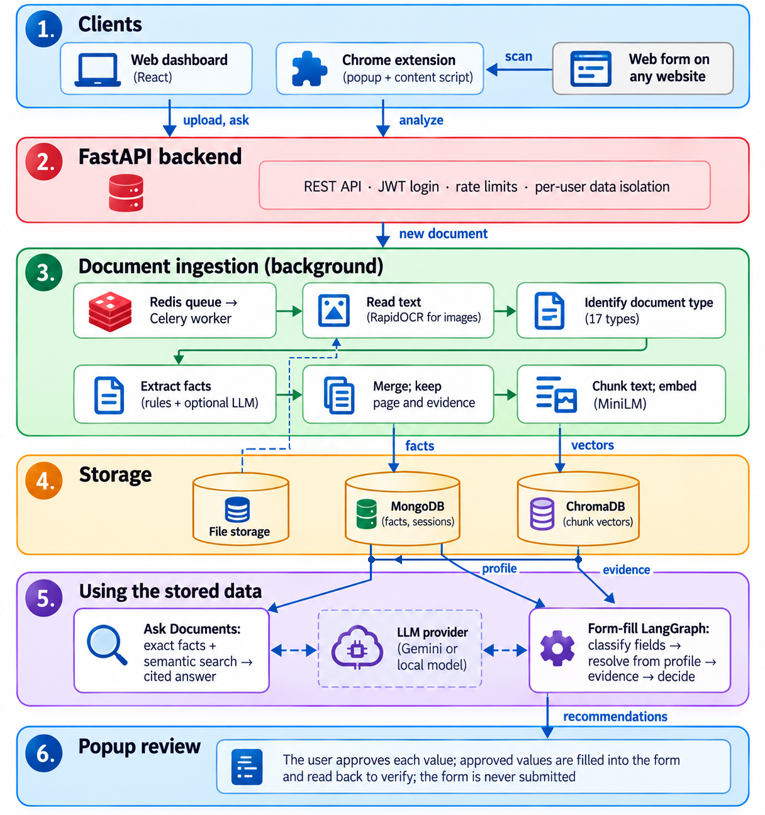
Figure 4.1 End-to-end architecture and data flow, from document upload to reviewed form filling
1. Clients: the user works through a web dashboard (upload, profile, questions) and a Chrome extension. The extension reads only the descriptions of a form’s fields, never their current values.
2. Backend: a FastAPI server checks the user’s token, applies rate limits and passes the user’s identifier into every database query, so that one user can never read another user’s data.
3. Ingestion: a new document is queued in Redis and processed by a Celery worker, which reads its text (with OCR for images), identifies its type, extracts the facts and merges them with their evidence, and splits the text into chunks and embeds them.
4. Storage: the original file is kept in file storage, the facts and form sessions in MongoDB, and the chunk embeddings in ChromaDB.
5. Using the stored data: Ask Documents answers questions from exact facts first and from semantic search over the chunks second, and the form-fill pipeline classifies form fields, takes values from the profile and, where needed, from cited document evidence. Both may call the LLM, but neither accepts an answer that is not supported by the stored data.
6. Review: the recommendations return to the extension popup, where the user approves, edits or skips each value before anything is filled.

4.2 Data Flow
Figure 4.2 is the level-1 data-flow diagram. It shows six processes, the data stores they read and write, and the optional LLM provider as an external entity.
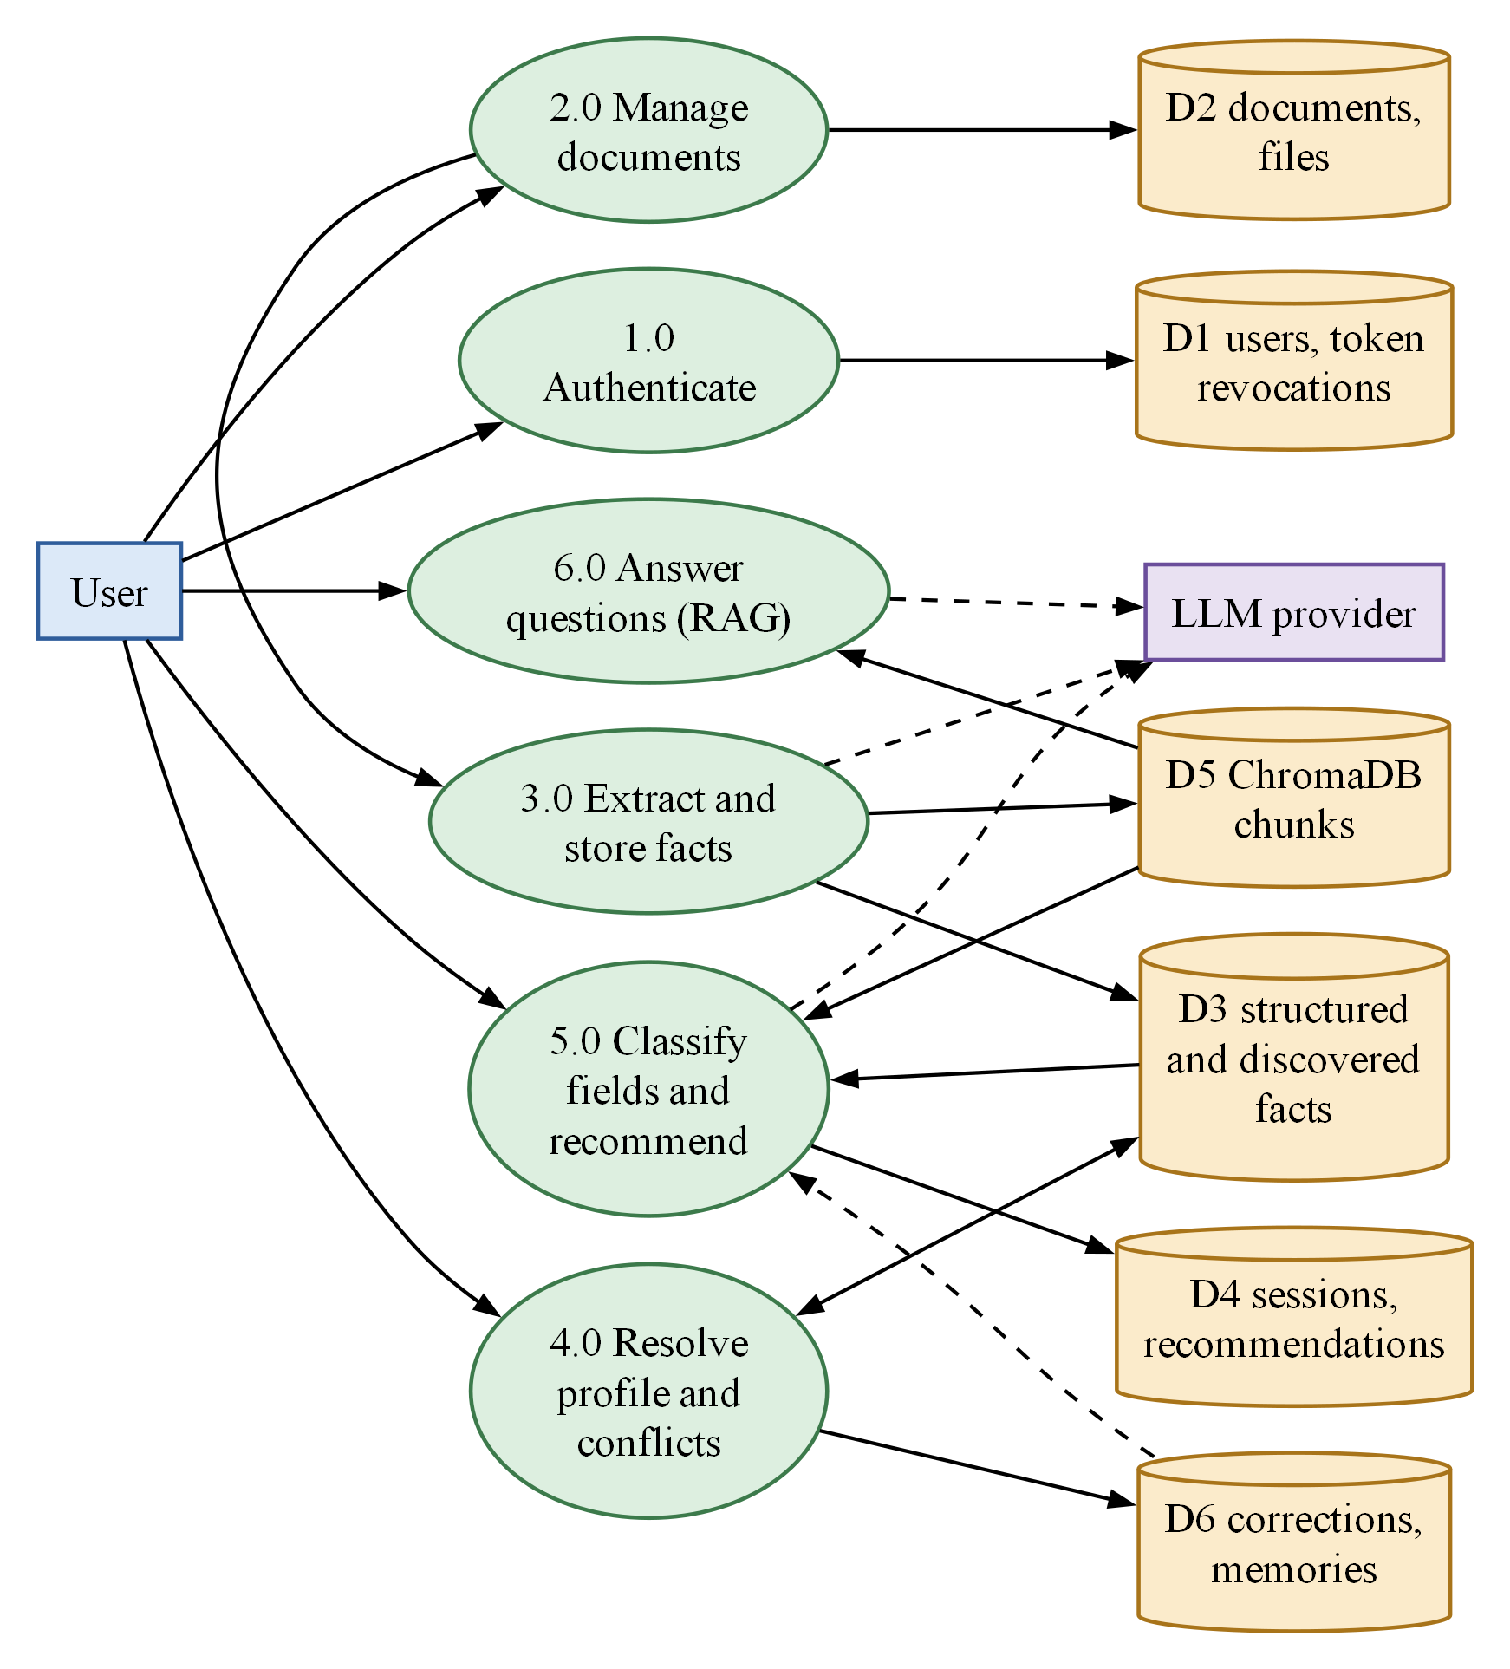
Figure 4.2 Data-flow diagram, level 1
The user signs in (1.0) and uploads documents (2.0). Each stored file is passed to fact extraction (3.0), which writes facts to the fact store D3 and chunk embeddings to D5. Profile and conflict resolution (4.0) lets the user confirm or correct facts and records each correction in D6. Field classification and recommendation (5.0) reads the facts, the document chunks and saved answers, and writes form sessions and recommendations to D4. Question answering (6.0) reads the chunks and facts. Only processes 3.0, 5.0 and 6.0 may call the LLM.

4.3 Database Design
As explained in Section 2.1.1, MongoDB stores records as flexible documents grouped into collections. Almost every record carries the owner’s user_id, and every query and deletion includes it. A separate ChromaDB collection holds the chunk embeddings, labelled with the same user_id and document_id so that search results always belong to the person asking.
Figure 4.3 The entity relationship diagram. A user owns documents, structured facts, form sessions, corrections, and saved answers. A document owns its processing records and facts, and a form session owns one recommendation per field.
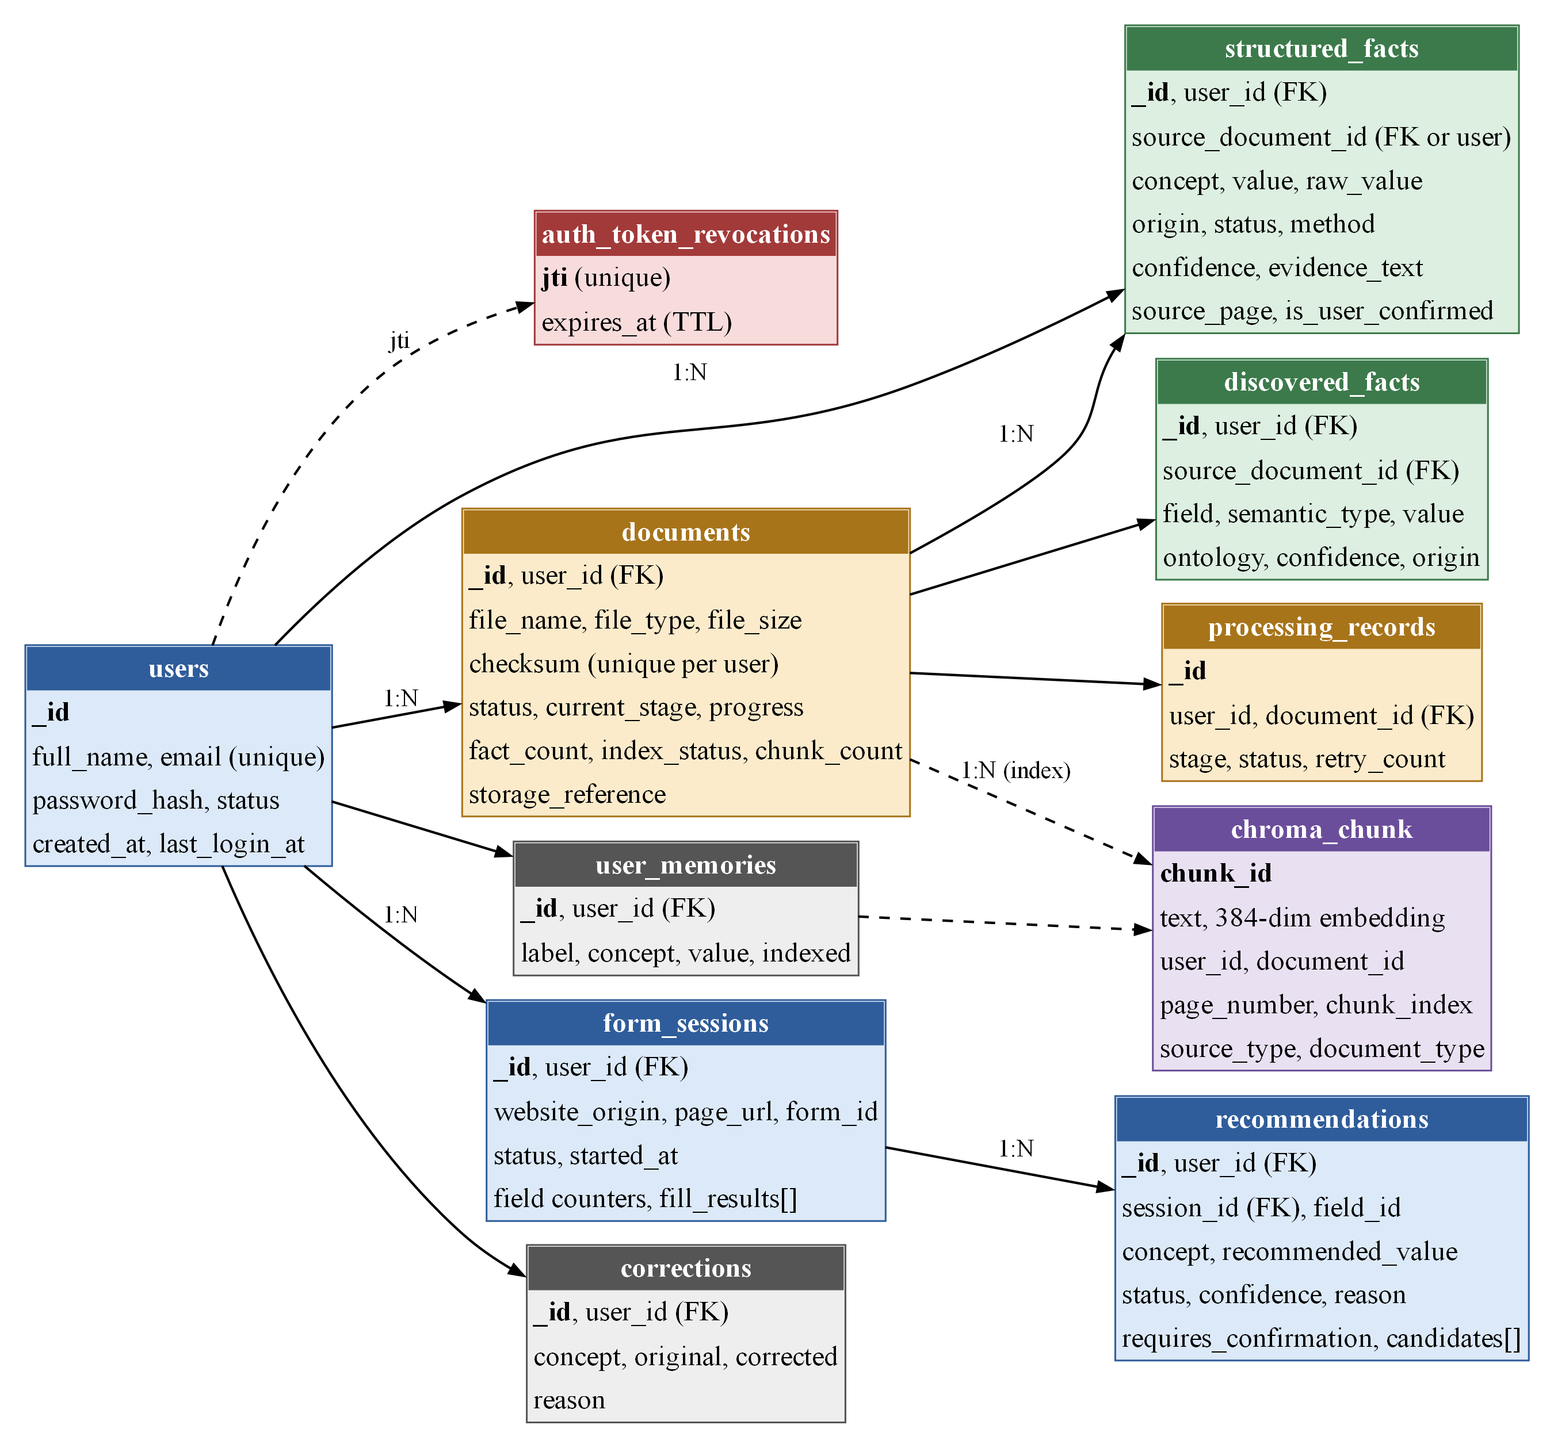
Figure 4.3 Entity–relationship diagram of the MongoDB collections and the ChromaDB chunk index
Two design choices ensure data consistency. First, conflicts are not stored but are computed on demand from the current facts, so deleting or reprocessing a document cannot leave an outdated conflict. Second, when a document is reprocessed, its previous facts and chunks are deleted first, preventing duplication. Tables extracted from documents, like subject-wise marks or bank transactions, are stored as discovered facts, while form-fillable concepts are represented as structured facts.

4.4 Form-Filling Pipeline
Form analysis is implemented as a LangGraph state graph of seven steps sharing one state object. Two conditional steps are skipped when not needed, which keeps most analyses free of LLM calls:
1. sanitize: blocks password, payment, OTP, CAPTCHA, hidden and file fields, and sets aside fields whose text looks like an injected instruction.
2. deterministic_classify: per field to concept using autocomplete attribute label placeholder, name, and surrounding text against our dictionary of ontology synonyms. A label in a "Father's details" field is not given the user's name.
3. llm_classify (only if needed): sends one batched request for the fields the rules could not resolve, and the answer is accepted only if it names a known concept with enough confidence.
4. resolve_profile: takes values from the user's profile, marking any concept with disagreeing documents as needing review.
5. resolve_documents (only if needed): get the document chunks for all the empty fields and asks the LLM for a value that must be present within cited chunk; and anything else is thrown away.
6. decide and persist: the decide step applies the rules of Section 4.5, and the persist step stores one recommendation per field.

4.5 Decision Rules
Figure 4.4 is the flowchart of the decide step, which gives every field its final status. Each path ends at a single End terminator, where the recommendation is stored.
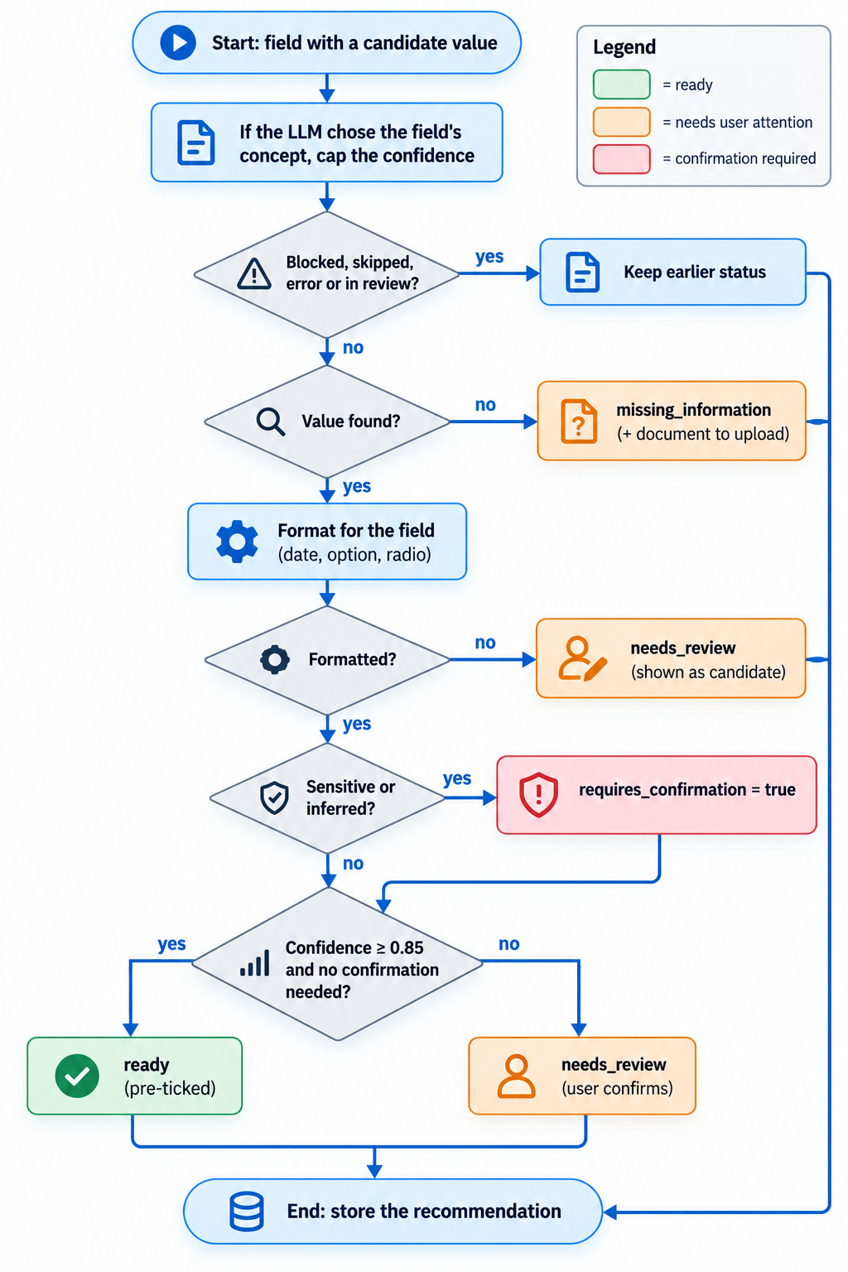
Figure 4.4 Flowchart of the decide step of the form-filling pipeline
A field that was already blocked remains blocked, and a field without a value becomes missing information, with a hint about, which document usually contains it. Otherwise, the value is formatted for the field. If formatting fails, the value is shown only as a candidate. Sensitive concepts and inferred values always require confirmation. A field is ready, and so pre-ticked in the popup, only when its confidence is at least 0.85 and no confirmation is required. Every other field is marked needs review. When the LLM chose the field’s concept, the value’s confidence is capped by the confidence of that choice, so an uncertain mapping cannot produce a ready value.

4.6 Security Design
- Accounts: passwords are hashed with bcrypt [29], access tokens are JSON Web Tokens valid for 30 minutes and revoked on sign-out, and repeated failed logins are rate-limited.
- Isolation: every MongoDB and ChromaDB operation is filtered by the user’s identifier.
- Uploads: the file extension, declared type, content signature (magic bytes), size limit of 10 MB and duplicate checksum are all checked.
- Prompt injection: page and document text are placed in explicitly marked data blocks, six injection patterns are identified, and the output of LLMs must cite data stored in the knowledge bank [6], [7].
- Browser: the extension uses on-demand page access, keeps its token away from page scripts, never reads field values and never submits.

Chapter Summary
The design was presented through the end-to-end architecture, the level-1 data flow, the database design, the seven-step form-filling pipeline, the decision flowchart and the security controls. The main design decisions are a single ontology, rules before models, answers grounded in stored evidence, conflicts computed rather than stored, per-user isolation and mandatory user review.

Chapter 5
RESULT ANALYSIS: SNAPSHOTS
This chapter shows the working system and analyses its measured results. All screenshots were captured from the running system with the Playwright browser-automation library. They use a dedicated demonstration account loaded with fifteen synthetic documents for a fictional applicant, and no real personal data appears in this report. The measured results come from an evaluation run on the same data, using the Gemini model and the all-MiniLM-L6-v2 embedding model.

5.1 Dashboard and Document Processing
Figure 5.1 shows the dashboard after all fifteen documents were processed. It reports 15 documents, 90 profile values (13 confirmed by the user), 11 conflicts to resolve and 19 field reviews pending. Each card links to the page where the user can act on it.
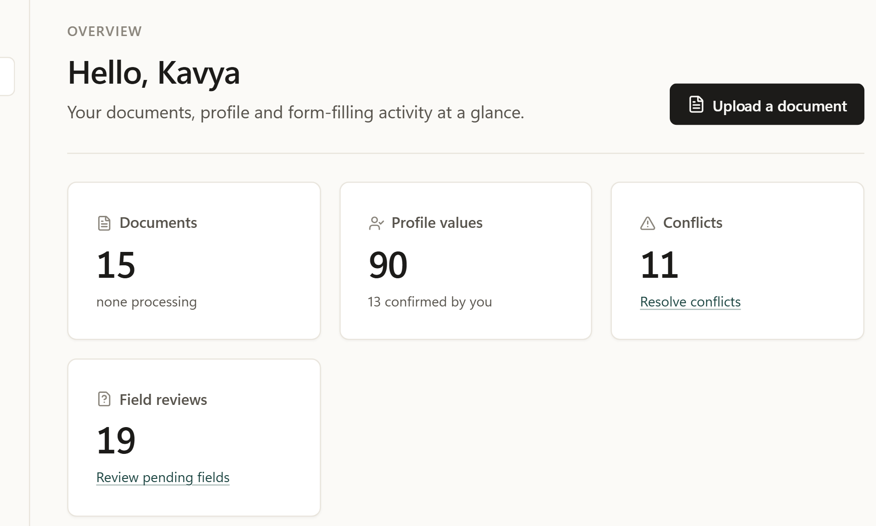
Figure 5.1 Dashboard overview of the demonstration account
Figure 5.2 displays the record of Class 12 mark sheet. The search system recognized the type of document and for each value, showed how it was derived (Extracted or Normalised), the confidence and the evidence text with its page. This evidence trail is the foundation of Objective 1.
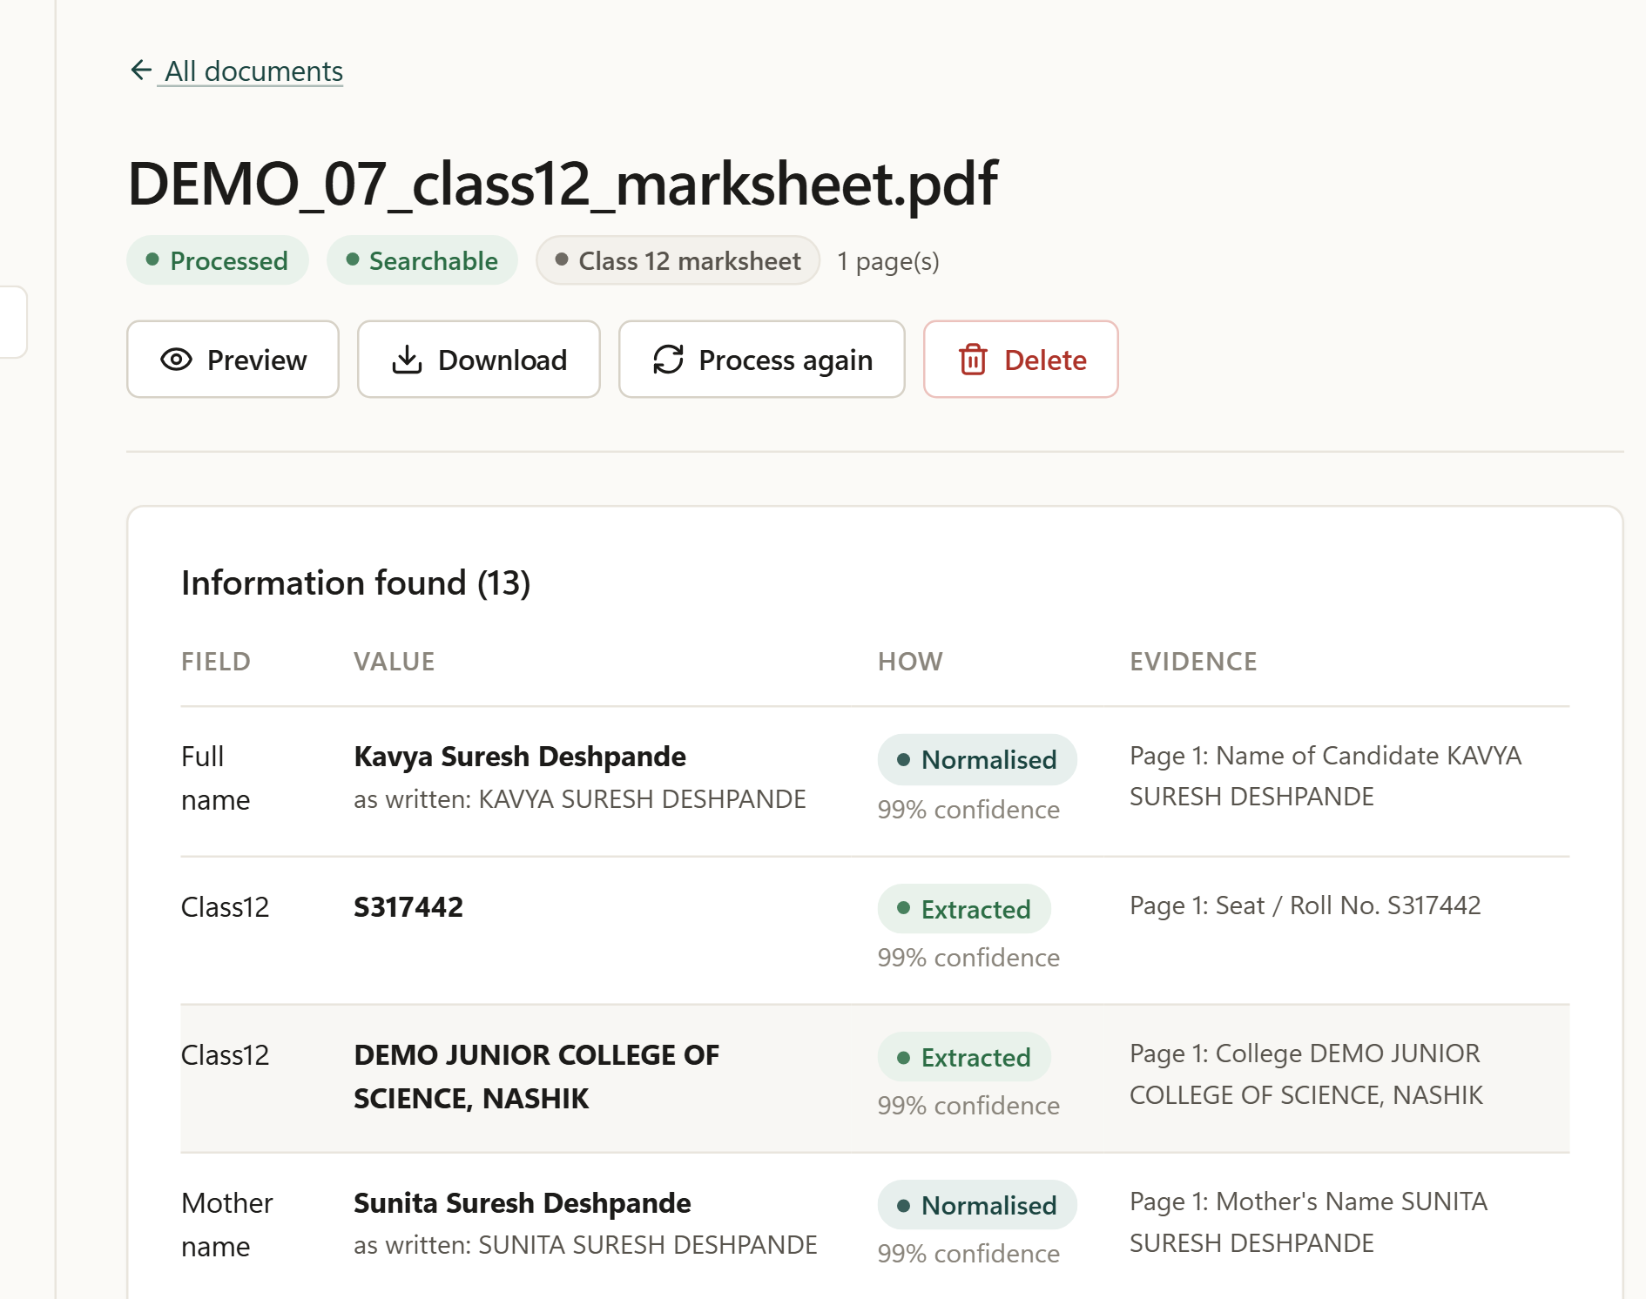
Figure 5.2 Facts extracted from the Class 12 mark sheet, with evidence

5.2 Profile and Conflicts
Figure 5.3 shows the Profile page, which groups values by topic. Each value lists the documents that support it. The father’s name, for example, is supported by eight documents. The user can confirm, edit or delete each value.
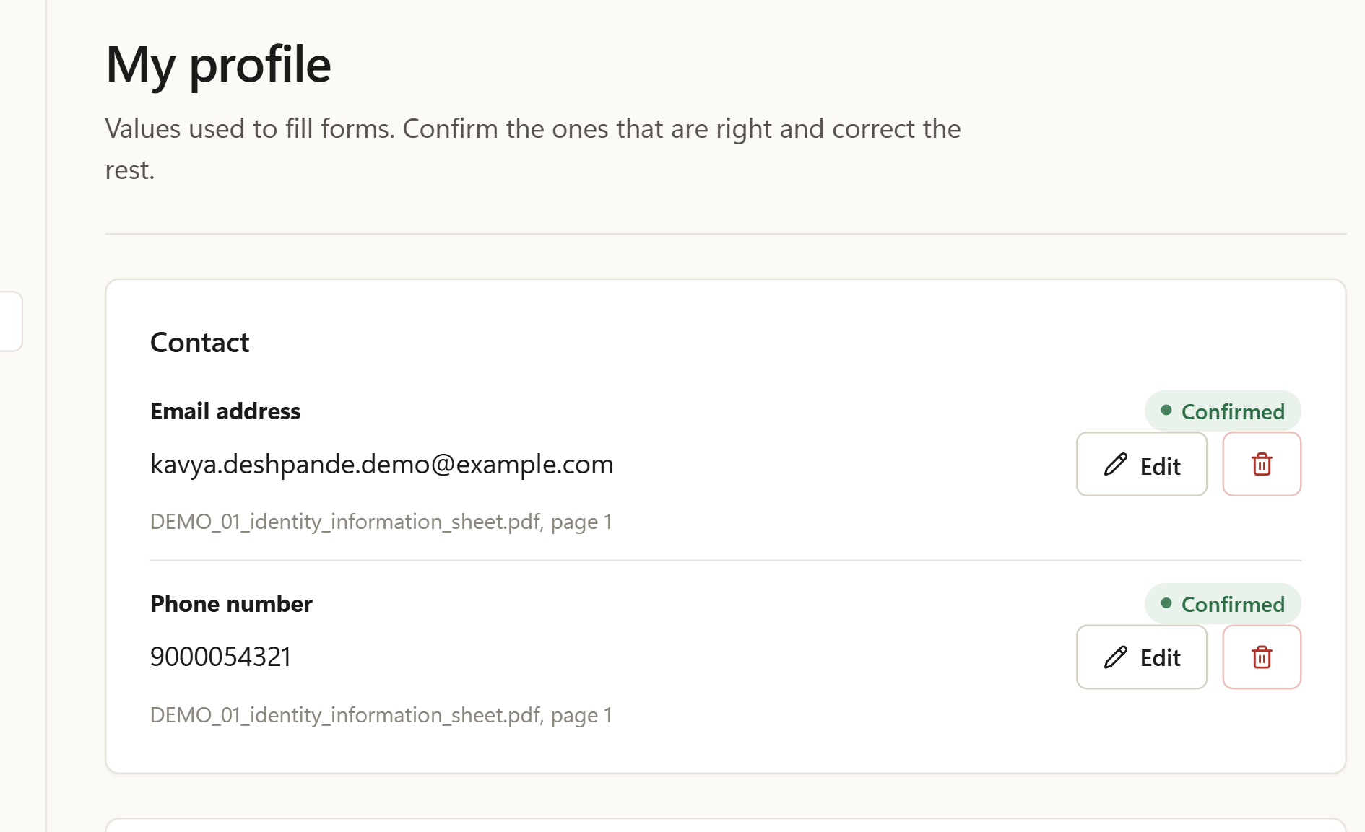
Figure 5.3 Profile page with the supporting documents of each value
Figure 5.4 shows a real disagreement found by the system, in which the caste validity certificate contains two different dates (20/11/2025 and “Date of Issue 09/07/2025”). Both candidates are shown with their evidence, and nothing is filled until the user chooses (Objective 2).
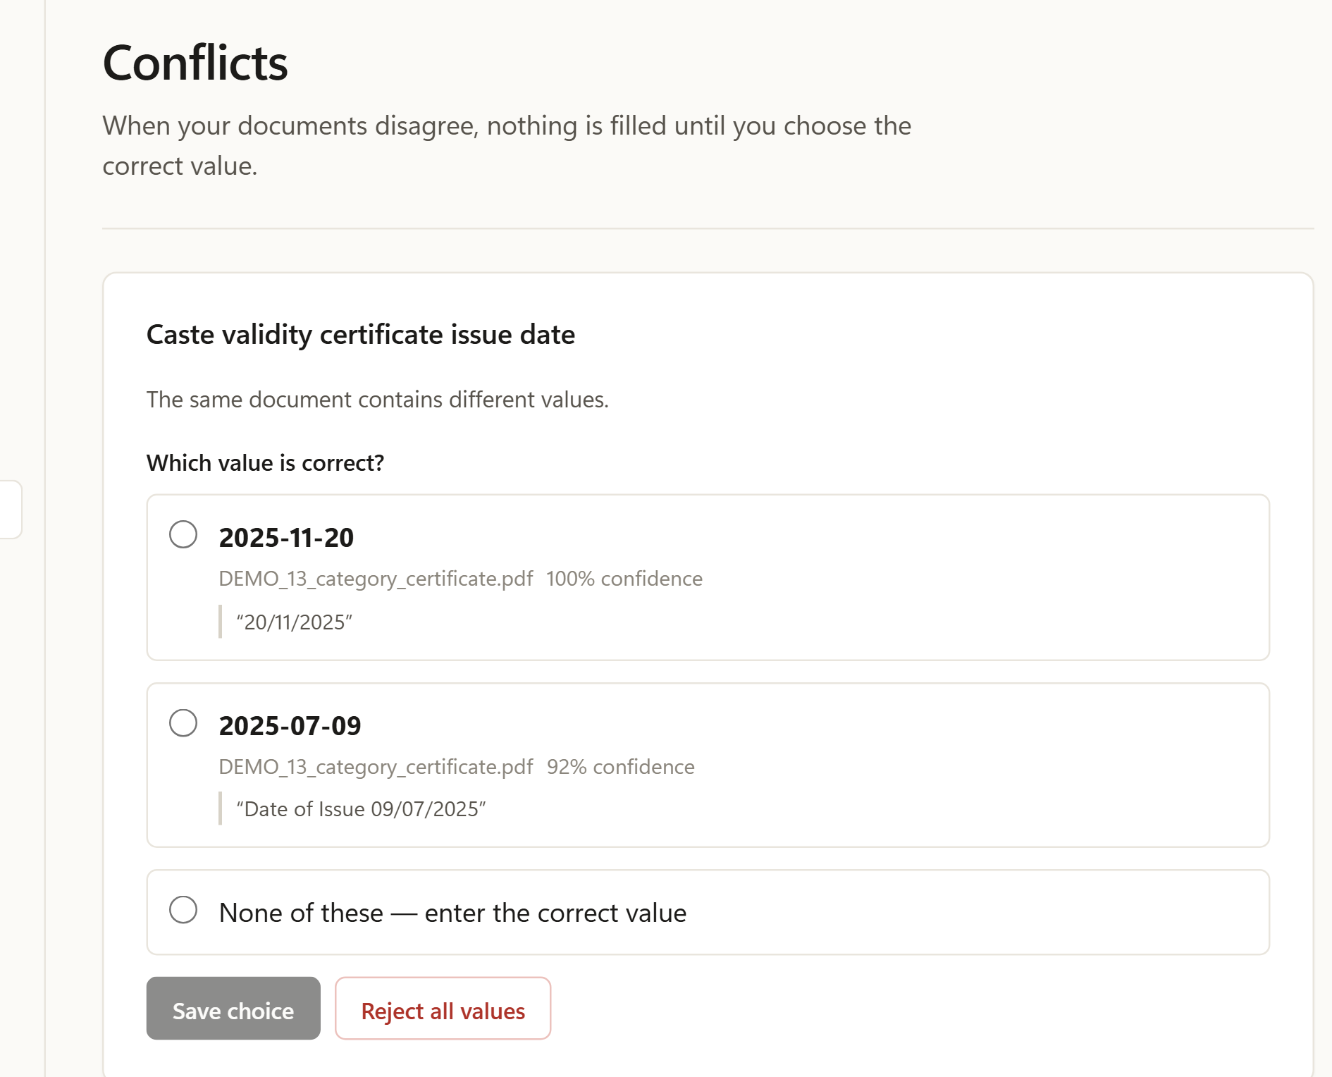
Figure 5.4 Conflict between two dates found in one certificate

5.3 Ask Documents
Figure 5.5 shows the answer to “What was my Class 12 percentage, and which document states it?” The answer (87.20%) comes from an exact fact, and the Sources panel quotes the cited passage of the Class 12 mark sheet (Objective 4).
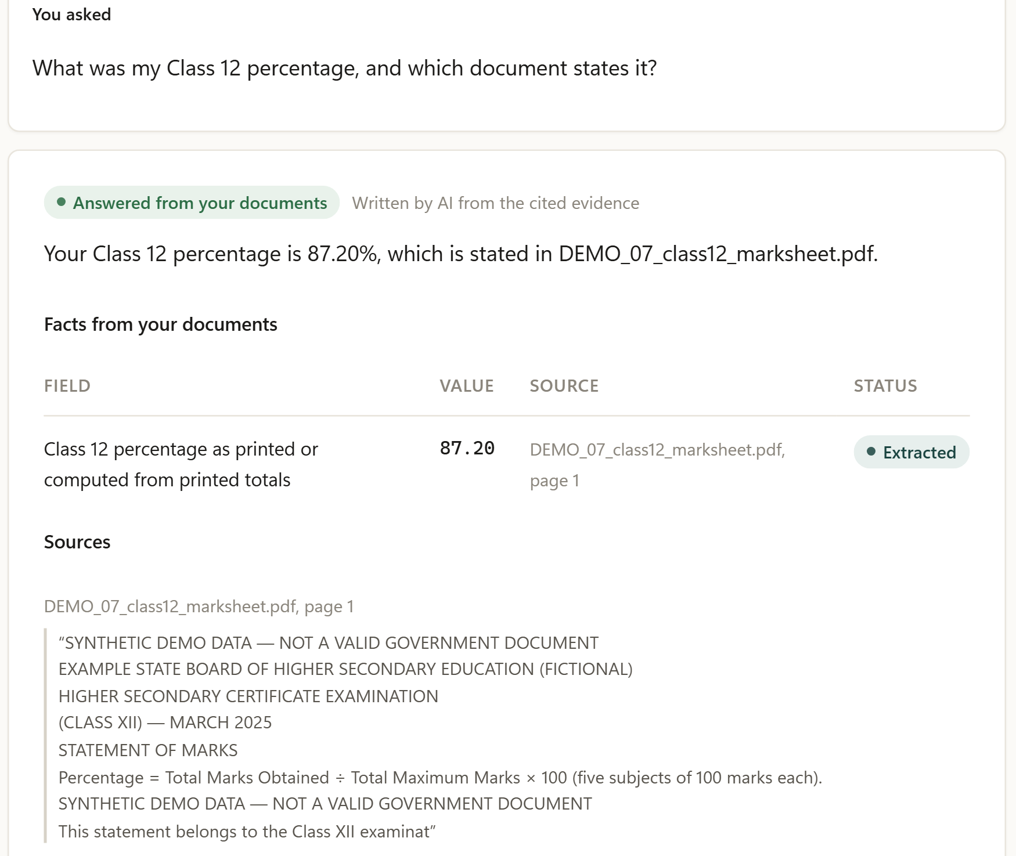
Figure 5.5 Ask Documents: answer with the cited source

5.4 Browser Extension
Figure 5.6 shows the extension on a synthetic Class 12 application form. On the left, after analysis, 23 of 25 fields are ready and 2 need attention because the passing month and result are not in the documents. On the right, after the user chose Fill, all 23 values were filled and read back from the page, and the popup confirms that nothing was submitted.
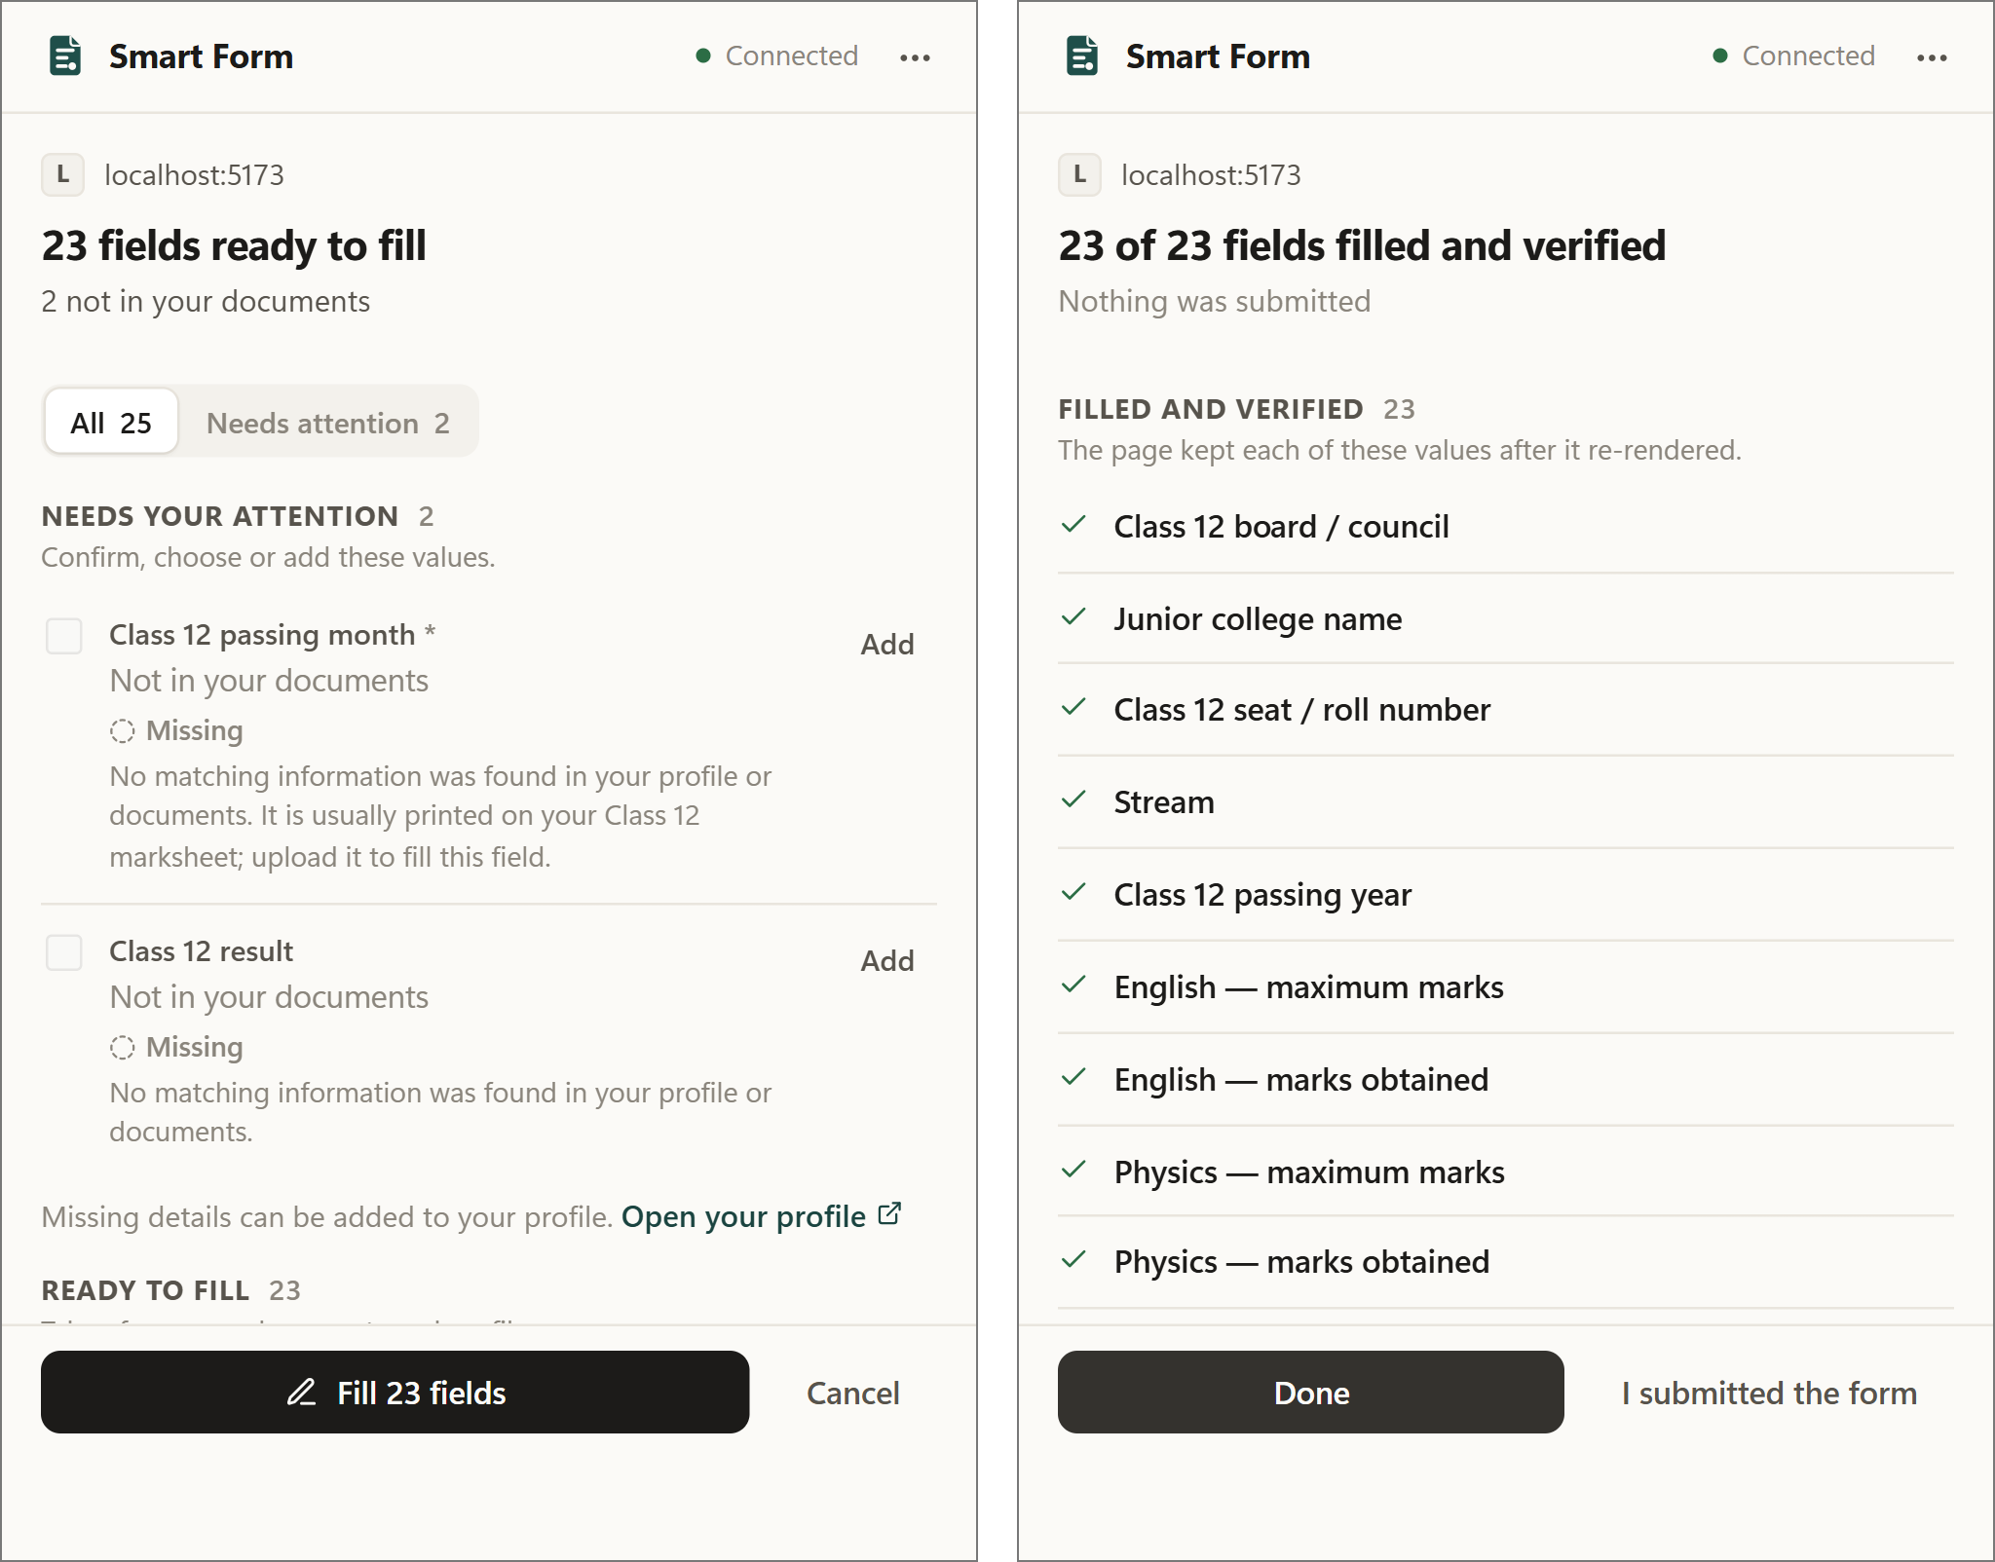
Figure 5.6 Extension popup: review before filling (left) and verified result (right)
Figure 5.7 shows part of the filled form. The subject-wise marks were filled and verified. The figure also shows one filling error. The “Elective language” row, which the mark sheet does not contain, received the total marks (500 and 436). Such errors are counted in Table 5.2.
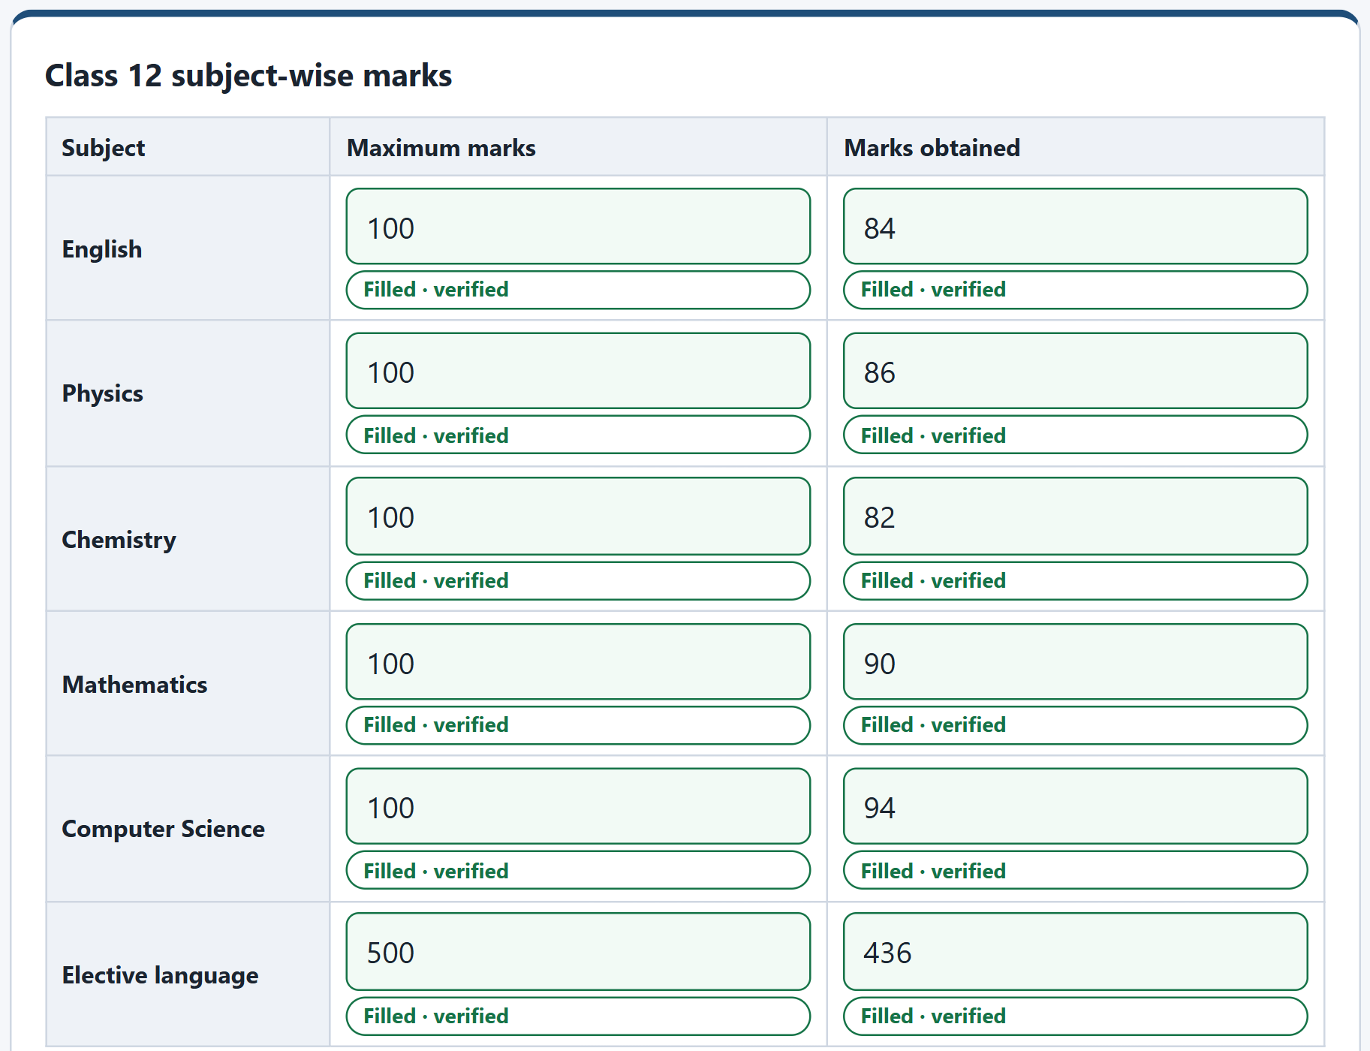
Figure 5.7 Filled subject-wise marks on the synthetic Class 12 form

5.5 Measured Results
Table 5.1 summarises extraction, retrieval and question answering on the fifteen synthetic documents. The answers were compared with a hidden answer key that the system never reads. Each result is given as the number of successful cases out of the number of cases evaluated, and each percentage is that ratio multiplied by 100. For example, 128 of the 132 expected fields were extracted exactly, and 128 / 132 = 97.0%.
Table 5.1 Extraction, retrieval and question-answering results (15 synthetic documents)
Measure | Successful / total (%)
Document type identified correctly | 15 / 15 (100%)
Expected fields extracted with the exact value | 128 / 132 (97.0%)
Expected fields extracted exactly from scanned images | 44 / 45 (97.8%)
Expected fields extracted exactly from digital PDFs | 84 / 87 (96.6%)
Table rows exactly right (subject marks, transactions, members) | 40 / 40 (100%)
Documents stored in MongoDB / indexed in ChromaDB | 15 / 15 and 15 / 15
Retrieval queries with the correct document ranked first | 14 / 15 (93.3%)
Retrieval queries with the correct document within the top four | 15 / 15 (100%)
Ask Documents questions answered correctly | 28 / 28 (100%)
Answers citing the correct source (questions with an expected source) | 23 / 23 (100%)
Answers containing forbidden or invented values | 0 / 28 (0%)
Median answer time | 0.08 s

Table 5.2 gives the outcome of filling the fifteen matching forms through the browser extension.
Table 5.2 Browser autofill results on 15 synthetic forms
Outcome on 15 synthetic forms (real extension, real backend) | Count
Expected values to be filled, according to the answer key | 204
Fields filled correctly | 112
Fields filled incorrectly (6 with a wrong value and 3 filled when they should stay empty) | 9
Expected values held for the user’s review (not filled) | 84
Expected values missed silently | 0
Expected fields not detected on the page | 2
Fields whose value is absent from the documents, correctly left empty | 12 of 15
Fields reserved for the user’s own choice that the system touched | 0 of 15
Forms submitted by the system | 0 of 15

The 204 expected values are fully accounted for. Of these, 112 were filled correctly, 6 were filled with a wrong value, 84 were held for review, 2 were not detected on the page and none was missed silently (112 + 6 + 84 + 2 + 0 = 204). In addition, 3 of the 15 fields that should have stayed empty were filled. Of the 121 values the system filled automatically (112 correct and 9 incorrect), 112 were correct, a precision of 112 / 121 = 92.6%. The system favoured caution. It held 84 expected values for review instead of filling them (for example sensitive values, values from disagreeing documents and values below the 0.85 confidence threshold), and no form was submitted. The OCR benchmark on 30 rendered documents gave field recall of 0.948 for clean scans, 0.850 for pages skewed by 3–4°, 0.948 for pages rotated by 90° and 0.855 for simulated phone photographs, at 2.6 to 7.8 seconds per page on a CPU. In a comparison of language models on six grounded questions and eight hard field-classification cases, Gemini answered 6/6 and 8/8, the local qwen2:7b model 4/6 and 5/8, and gemma:2b 2/6 and 1/8, which is why Gemini is the primary model and the local model is only a fallback whose mappings always need review.

5.6 Analysis
- Objectives 1 and 4: extraction (97.0% exact fields) and question answering (28/28 with sources) met their goals on the synthetic set.
- Objective 2: disagreements, such as the two issue dates in Figure 5.4, were shown to the user instead of being resolved silently.
- Objective 3: 112 fills correct; 9 errors. Three errors confused the correspondence and permanent addresses (two PINs and one address), three indicated the wrong relationships for household members, and three filled in a value in the cell that should have been empty, including the elective-language row of Figure 5.7.
- Objective 5: no form was submitted, no field reserved for the user was touched, and every filled value was read back from the page.
- Scope of the evidence: the percentages are measured on the synthetic set, which has a known answer key. The system was also tested on real user documents (Table B.1), which are not included in these figures to protect the users’ privacy.

Chapter Summary
Seven snapshots showed the working system from processed documents to a filled and verified form, including one real disagreement and one real filling error. On fifteen synthetic documents and forms, the system identified every document type, extracted 97.0% of expected fields, answered all 28 questions with sources and filled 112 fields correctly and 9 incorrectly, without submitting any form.

Chapter 6
TESTING
This chapter details the testing of the system, the approach and the circumstances of the testing, the test inventory, test cases and results, and then considers how well the aims of Chapter 1 were attained and lists the key findings. All figures quoted are taken from the recorded test runs.

6.1 Testing Strategy
Testing is organised in four levels. Unit and API tests check one module or one server endpoint at a time. Integration tests run against a real ChromaDB service with the real embedding model. Browser end-to-end tests load the built extension into a real Chromium browser with Playwright and fill a test form through the whole system. Finally, the evaluation of Chapter 5 measures accuracy on synthetic documents and forms.
The default backend test run will never touch your data or call a paid service. The test setup uses a fake language model (a dummy that always returns valid fixed answers), a scratch file store, and a randomly named database that is then deleted. Tests that require ChromaDB or a real LLM provider are annotated and are only run on demand. A CI workflow runs the unit, integration, dashboard, extension, and browser tests on every repository push.

6.2 Test Environment
All tests were run on a laptop with an Intel Core i5-13450HX processor (10 cores) and 16 GB of memory (15.7 GB usable), running Windows 11 Home, Python 3.11.9, Node.js 22.14.0, Docker 29.4.0 with Compose v2, MongoDB 8 and ChromaDB in Docker containers, and Playwright-managed Chromium. Backend tests use pytest, and dashboard and extension tests use Vitest with a simulated browser page (jsdom).

6.3 Test Inventory
Table 6.1 groups the 301 backend tests by area, with the number of tests in each area, and lists the dashboard and extension suites. The counts were collected from the test runner itself.
Table 6.1 Automated test inventory
Area | What is tested | Tests
Accounts and configuration | Registration, login, token expiry and revocation, rate limits, unsafe settings rejected | 21
Documents and processing | Valid and invalid uploads, duplicates, corrupted files, reprocessing, deletion, isolation | 19
Indian documents and OCR | 17 document types, identifiers, mark-sheet tables, OCR layout, chunking | 93
Extraction and ontology | Rule-based extraction, normalisation, merging, alias matching | 32
Profile and conflicts | Conflict detection, resolution, corrections, deleting all data | 10
Form filling | Field classification, recommendations, formatting, decisions, exam forms | 62
Ask Documents and RAG | Question planning, grounded answers, sources, cross-user protection | 41
LLM and prompt safety | Injection patterns, untrusted blocks, provider errors and retries | 16
Platform | Health checks, error format, cross-origin rules, extension manifest | 7
Backend total |  | 301
Dashboard (7 files) | Sign-in, documents, profile, Ask page, exam readiness, demo data, badges | 30
Extension (8 files) | Field detection, filling, uploads, document types, API client, popup flow | 112

6.4 Test Cases
Table 6.2 lists representative test cases. The expected result is the assertion made by the named automated test, and the actual result is the outcome recorded for that test.
Table 6.2 Representative test cases
ID | Test case (automated test) | Expected result | Actual result | Status
TC-01 | Wrong password and unknown e-mail | Same error for both | Same 401 error | Pass
TC-02 | Token sent in the query string | Request refused | Refused | Pass
TC-03 | Upload a renamed executable or fake PDF | Rejected, nothing stored | Rejected | Pass
TC-04 | Upload the same file twice | Duplicate reported | Duplicate reported | Pass
TC-05 | Index fails during processing | Facts kept, index marked failed | As expected | Pass
TC-06 | Two documents disagree on a value | Conflict listed with sources | Listed with sources | Pass
TC-07 | “Name” inside a father’s section | User’s own name not used | Not used | Pass
TC-08 | Field with no fact and no evidence | Missing, no value invented | Missing | Pass
TC-09 | Field text says “ignore previous instructions” | Field quarantined, not sent to LLM | Quarantined | Pass
TC-10 | LLM value not present in cited text | Value discarded | Discarded | Pass
TC-11 | Class 12 question with both mark sheets | Never answered from Class 10 | Correct mark sheet | Pass
TC-12 | User B asks for user A’s data | Refused or not found | Refused | Pass
TC-13 | Page with password, hidden and honeypot fields | Those fields not listed | Not listed | Pass
TC-14 | Fill a framework-controlled input | Value kept and verified | Kept and verified | Pass
TC-15 | Complete fill in real Chromium | Values filled, form not submitted | Not submitted | Pass

6.5 Test Results
Table 6.3 summarises the recorded results of the executed test suites. For each suite it gives the number of test cases, the number that passed and failed, and the pass percentage, calculated as the number passed divided by the number executed, multiplied by 100. The vector-database tests need a running ChromaDB service and are therefore run as a separate suite (row 2).
Table 6.3 Test results: total, passed and failed test cases
Test suite (tool) | Total | Passed | Failed | Pass %
Backend unit and API (pytest, mock LLM) | 301 | 301 | 0 | 100%
Vector-database integration (pytest, real ChromaDB) | 3 | 3 | 0 | 100%
Dashboard (Vitest) | 30 | 30 | 0 | 100%
Extension (Vitest) | 112 | 112 | 0 | 100%
Subtotal (final recorded test run) | 446 | 446 | 0 | 100%
Browser end-to-end (Playwright, Chromium), earlier recorded run | 7 | 7 | 0 | 100%
Total of recorded results | 453 | 453 | 0 | 100%

All 446 unit, API, integration, dashboard and extension tests passed in the final recorded test run (301 + 3 + 30 + 112 = 446). The seven browser end-to-end tests, which exercise the built extension in a real Chromium browser, passed in an earlier recorded run and are reported from that record. Together, the recorded results comprise 453 test cases, all of which passed, a pass percentage of 453 / 453 = 100%. Four optional tests that call a paid LLM provider were not executed and are therefore not included in these figures. The accuracy evaluation of Chapter 5 is reported separately and is not counted here.

6.6 Discussion
These test suites can all be constructed based on the guarantees the design relies on: refusal of invalid requests, isolation at the user level, grounded LLM outputs, and the cardinal rule that at no point do users ever have anything filled in or submitted for them. Really all of these test suites pass reliably proves that the functionality we have implemented works as expected. Penetration load accessibility, and OCR tests on real scans are out of scope for this phase and will be discussed as future work in Chapter 7.

6.7 Achievement of Objectives
Table 6.4 compares each objective with the evidence from Chapter 5 and from the tests of this chapter.
Table 6.4 Achievement of the objectives
Objective | Status | Evidence
1. Document understanding with evidence | Achieved | Type identified for 15/15 documents, 97.0% of fields exact (Table 5.1)
2. Verified profile with conflicts | Achieved | Conflicts shown with sources (Figure 5.4), test TC-06
3. Semantic form filling | Achieved, with errors | 112 correct and 9 incorrect fills, 84 held for review (Table 5.2)
4. Grounded question answering | Achieved | 28/28 questions correct with sources (Table 5.1)
5. Safety and verification | Achieved | No form submitted, all 453 recorded test cases passed (Table 6.3)

6.8 Principal Findings
- Rules before models: set in advance matching over a common ontology will fix most fields, requiring language model only for the rest, which is ambiguous, keeping cost delay risk low.
- Disagreements must be visible: real sets of documents disagree, and displaying the difference was more trustworthy than any auto-selection.
- Grounding checks are cheap and effective: see if a value is grounded in the cited text eliminates a class of "invented answers" with no need for a second model call.
- Caution needs balance: of the 84 that were held for further review, this prevented the wrong fill but require more work by the user. The other errors indicate where we need more context when matching fields.

Chapter Summary
The system was evaluated over four iterations. All 446 unit, API, integration, dashboard, and extension tests passed in the last logged test run, and all 7 browser end-to-end tests passed in a logged previous run, resulting in 453 total test cases with no failures. Relative to this data and as shown in Chapter 5, all five objectives have been met, with a handful of usability improvements to form-filling errors.

Chapter 7
CONCLUSION & FUTURE WORK
This chapter finishes off the report and presents the other restrictions and the way forward.

7.1 Conclusion
So we designed a method for automating web form filling from a person's own documents while making each value referenceable and every choice user-controlled. We proposed the Smart Form Auto-Filling System, a privacy-conscious approach that brings together document understanding, a common ontology of personal-data concepts and retrieval-augmented generation, and a browser extension that fills only user consented values.
The approach is based on a handful of principles. Documents, even scanned ones, are transformed into structured facts that are annotated with source and evidence. Conflicts between documents are presented to the user as conflicts rather than being resolved behind the scenes. Form fields are initially matched to ontology concepts using a set of fixed rules and the language model is only queried for ambiguous fields and a value is only accepted if grounded in persisted evidence.
The testing on synthetic documents and forms, with the added automated test suites, proved that the goals of the project have been accomplished: document facts were extracted accurately; questions for the documents were accurately answered with the sources correctly indicated; forms were completed with minimal errors; no form was submitted without a user. In all areas, the system was quite conservative and new, sensitive, or uncertain values were held for verification rather than completed.
This work demonstrates that evidence-based, user-validated form-filling is a workable alternative to current autofill and to autonomous web agents. Using set in advance rules before a language model is low cost and low risk, and straightforward grounding validation guards against fabricating values. As the evaluation used synthetic data, it measured system behaviour for these cases rather than accuracy on real documents, and the limitations below guide future work.

7.2 Limitations and Future Work
Table 7.1 pairs each known limitation with the work proposed to address it.
Table 7.1 Limitations and proposed future work
Current limitation | Proposed future work
Accuracy measured only on synthetic documents and forms | Build an anonymised benchmark of real documents and forms and report accuracy per concept
Errors with similar fields (correspondence and permanent address, household relationships) | Use section headings and the form’s structure more strongly, and ask the user when two concepts compete
English OCR only, and Indian scripts and handwriting are not read | Add multilingual OCR models and evaluate them on real scans
Chrome only, and fields added after the scan need a new scan | Port to other Manifest V3 browsers, and watch the page for new fields and multi-step forms
Examination requirement profiles not verified against official bulletins | Verify each profile against the current official notification before use
No load, penetration or accessibility testing | Add these tests and run the paid-provider tests with synthetic data

Three further extensions are promising. First, a fully local language model would keep all document text on the user’s computer (an optional local fallback exists but is less accurate). Second, graph-based retrieval such as HippoRAG [21] could answer questions that combine several facts. Third, a per-site consent list would let the user trust selected portals while keeping the review step for every fill.

References
[1] N. Reimers and I. Gurevych, “Sentence-BERT: Sentence embeddings using Siamese BERT-networks,” in Proc. 2019 Conf. Empirical Methods in Natural Language Processing and 9th Int. Joint Conf. Natural Language Processing (EMNLP-IJCNLP), Hong Kong, China, Nov. 2019, pp. 3982–3992, doi: 10.18653/​v1/​D19-1410.
[2] V. Karpukhin et al., “Dense passage retrieval for open-domain question answering,” in Proc. 2020 Conf. Empirical Methods in Natural Language Processing (EMNLP), Online, Nov. 2020, pp. 6769–6781, doi: 10.18653/​v1/​2020.emnlp-main.550.
[3] P. Lewis et al., “Retrieval-augmented generation for knowledge-intensive NLP tasks,” in Advances in Neural Information Processing Systems 33 (NeurIPS 2020), Online, Dec. 2020, pp. 9459–9474. [Online]. Available:
https://proceedings.neurips.cc/​paper_files/​paper/​2020/​hash/​6b493230205f780e1bc26945df7481e5-Abstract.html
[4] A. Asai, Z. Wu, Y. Wang, A. Sil, and H. Hajishirzi, “Self-RAG: Learning to retrieve, generate, and critique through self-reflection,” in Proc. 12th Int. Conf. Learning Representations (ICLR), Vienna, Austria, May 2024, pp. 9112–9141. [Online]. Available:
https://proceedings.iclr.cc/​paper_files/​paper/​2024/​hash/​25f7be9694d7b32d5cc670927b8091e1-Abstract-Conference.html
[5] M. Liao, Z. Wan, C. Yao, K. Chen, and X. Bai, “Real-time scene text detection with differentiable binarization,” in Proc. AAAI Conf. Artificial Intelligence, vol. 34, no. 7, New York, NY, USA, Feb. 2020, pp. 11474–11481, doi: 10.1609/​aaai.v34i07.6812.
[6] K. Greshake, S. Abdelnabi, S. Mishra, C. Endres, T. Holz, and M. Fritz, “Not what you’ve signed up for: Compromising real-world LLM-integrated applications with indirect prompt injection,” in Proc. 16th ACM Workshop on Artificial Intelligence and Security (AISec ’23), co-located with ACM CCS, Copenhagen, Denmark, Nov. 2023, pp. 79–90, doi: 10.1145/​3605764.3623985.
[7] Y. Liu, Y. Jia, R. Geng, J. Jia, and N. Z. Gong, “Formalizing and benchmarking prompt injection attacks and defenses,” in Proc. 33rd USENIX Security Symp. (USENIX Security 24), Philadelphia, PA, USA, Aug. 2024, pp. 1831–1847. [Online]. Available:
https://www.usenix.org/​conference/​usenixsecurity24/​presentation/​liu-yupei
[8] S. Zhou et al., “WebArena: A realistic web environment for building autonomous agents,” in Proc. 12th Int. Conf. Learning Representations (ICLR), Vienna, Austria, May 2024, pp. 15585–15606. [Online]. Available:
https://proceedings.iclr.cc/​paper_files/​paper/​2024/​hash/​4410c0711e9154a7a2d26f9b3816d1ef-Abstract-Conference.html
[9] X. Deng et al., “Mind2Web: Towards a generalist agent for the web,” in Advances in Neural Information Processing Systems 36 (NeurIPS 2023), Datasets and Benchmarks Track, New Orleans, LA, USA, Dec. 2023, pp. 28091–28114, doi: 10.52202/​075280-1220.
[10] B. Zheng, B. Gou, J. Kil, H. Sun, and Y. Su, “GPT-4V(ision) is a generalist web agent, if grounded,” in Proc. 41st Int. Conf. Machine Learning (ICML), ser. PMLR, vol. 235, Vienna, Austria, Jul. 2024, pp. 61349–61385. [Online]. Available:
https://proceedings.mlr.press/​v235/​zheng24e.html
[11] H. He et al., “WebVoyager: Building an end-to-end web agent with large multimodal models,” in Proc. 62nd Annu. Meeting Assoc. Computational Linguistics (ACL), Vol. 1: Long Papers, Bangkok, Thailand, Aug. 2024, pp. 6864–6890, doi: 10.18653/​v1/​2024.acl-long.371.
[12] W. Hong et al., “CogAgent: A visual language model for GUI agents,” in Proc. IEEE/CVF Conf. Computer Vision and Pattern Recognition (CVPR), Seattle, WA, USA, Jun. 2024, pp. 14281–14290, doi: 10.1109/​CVPR52733.2024.01354.
[13] K. Cheng et al., “SeeClick: Harnessing GUI grounding for advanced visual GUI agents,” in Proc. 62nd Annu. Meeting Assoc. Computational Linguistics (ACL), Vol. 1: Long Papers, Bangkok, Thailand, Aug. 2024, pp. 9313–9332, doi: 10.18653/​v1/​2024.acl-long.505.
[14] K. You et al., “Ferret-UI: Grounded mobile UI understanding with multimodal LLMs,” in Computer Vision – ECCV 2024 (Lecture Notes in Computer Science, vol. 15122). Cham, Switzerland: Springer, 2024, pp. 240–255, doi: 10.1007/​978-3-031-73039-9_14.
[15] A. Drouin et al., “WorkArena: How capable are web agents at solving common knowledge work tasks?” in Proc. 41st Int. Conf. Machine Learning (ICML), ser. PMLR, vol. 235, Vienna, Austria, Jul. 2024, pp. 11642–11662. [Online]. Available:
https://proceedings.mlr.press/​v235/​drouin24a.html
[16] D. Lee et al., “Learning to contextualize web pages for enhanced decision making by LLM agents,” in Proc. 13th Int. Conf. Learning Representations (ICLR), Singapore, Apr. 2025, pp. 81039–81072. [Online]. Available:
https://proceedings.iclr.cc/​paper_files/​paper/​2025/​hash/​c995a913bc20ca39ce2231b8973be90a-Abstract-Conference.html
[17] I. Gur et al., “A real-world WebAgent with planning, long context understanding, and program synthesis,” in Proc. 12th Int. Conf. Learning Representations (ICLR), Vienna, Austria, May 2024, pp. 52690–52717. [Online]. Available:
https://proceedings.iclr.cc/​paper_files/​paper/​2024/​hash/​e91bf7dfba0477554994c6d64833e9d8-Abstract-Conference.html
[18] D. Nguyen et al., “GUI agents: A survey,” in Findings of the Assoc. Computational Linguistics: ACL 2025, Vienna, Austria, Jul. 2025, pp. 22522–22538, doi: 10.18653/​v1/​2025.findings-acl.1158.
[19] J. S. Park, J. O’Brien, C. J. Cai, M. R. Morris, P. Liang, and M. S. Bernstein, “Generative agents: Interactive simulacra of human behavior,” in Proc. 36th Annu. ACM Symp. User Interface Software and Technology (UIST ’23), San Francisco, CA, USA, Oct. 2023, pp. 1–22, doi: 10.1145/​3586183.3606763.
[20] J. Sun et al., “Think-on-Graph: Deep and responsible reasoning of large language model on knowledge graph,” in Proc. 12th Int. Conf. Learning Representations (ICLR), Vienna, Austria, May 2024, pp. 3868–3898. [Online]. Available:
https://proceedings.iclr.cc/​paper_files/​paper/​2024/​hash/​10a6bdcabbd5a3d36b760daa295f63c1-Abstract-Conference.html
[21] B. Jiménez Gutiérrez, Y. Shu, Y. Gu, M. Yasunaga, and Y. Su, “HippoRAG: Neurobiologically inspired long-term memory for large language models,” in Advances in Neural Information Processing Systems 37 (NeurIPS 2024), Vancouver, BC, Canada, Dec. 2024, pp. 59532–59569, doi: 10.52202/​079017-1902.
[22] Y. Xu, M. Li, L. Cui, S. Huang, F. Wei, and M. Zhou, “LayoutLM: Pre-training of text and layout for document image understanding,” in Proc. 26th ACM SIGKDD Int. Conf. Knowledge Discovery and Data Mining (KDD ’20), Virtual Event, CA, USA, Aug. 2020, pp. 1192–1200, doi: 10.1145/​3394486.3403172.
[23] M. Hartmann and M. Mühlhäuser, “Context-aware form filling for web applications,” in Proc. IEEE Int. Conf. Semantic Computing (ICSC), Berkeley, CA, USA, Sep. 2009, pp. 221–228, doi: 10.1109/​ICSC.2009.83.
[24] S. Wang, Y. Zou, B. Upadhyaya, and J. Ng, “An intelligent framework for auto-filling web forms from different web applications,” in Proc. IEEE 9th World Congress on Services (SERVICES), Santa Clara, CA, USA, Jun. 2013, pp. 175–179, doi: 10.1109/​SERVICES.2013.19.
[25] Y. Shao et al., “FormLM: Recommending creation ideas for online forms by modelling semantic and structural information,” in Proc. 2022 Conf. Empirical Methods in Natural Language Processing (EMNLP), Abu Dhabi, UAE, Dec. 2022, pp. 8133–8149, doi: 10.18653/​v1/​2022.emnlp-main.557.
[26] P. Alian, N. Nashid, M. Shahbandeh, and A. Mesbah, “Semantic constraint inference for web form test generation,” in Proc. 33rd ACM SIGSOFT Int. Symp. Software Testing and Analysis (ISSTA), Vienna, Austria, Sep. 2024, pp. 932–944, doi: 10.1145/​3650212.3680332.
[27] X. Lin, P. Ilia, and J. Polakis, “Fill in the blanks: Empirical analysis of the privacy threats of browser form autofill,” in Proc. ACM SIGSAC Conf. Computer and Communications Security (CCS), Virtual Event, USA, Nov. 2020, pp. 507–519, doi: 10.1145/​3372297.3417271.
[28] W. Wang, F. Wei, L. Dong, H. Bao, N. Yang, and M. Zhou, “MiniLM: Deep self-attention distillation for task-agnostic compression of pre-trained transformers,” in Advances in Neural Information Processing Systems 33 (NeurIPS 2020), Online, Dec. 2020, pp. 5776–5788. [Online]. Available:
https://proceedings.neurips.cc/​paper_files/​paper/​2020/​hash/​3f5ee243547dee91fbd053c1c4a845aa-Abstract.html
[29] N. Provos and D. Mazières, “A future-adaptable password scheme,” in Proc. 1999 USENIX Annu. Technical Conf., FREENIX Track, Monterey, CA, USA, Jun. 1999. [Online]. Available:
https://www.usenix.org/​legacy/​events/​usenix99/​provos.html

Appendix A: Source Code Excerpts
These listings are copied without modification from the project repository with the paths indicated below. Only the common leading indent has been removed. Each listing illustrates a design decision introduced in Chapter 4 and is preceded by a brief rationale.

A.1 Construction of the form-filling graph
The seven steps of Section 4.4 are added as nodes. Two conditional edges skip LLM classification when every field is already resolved, and skip document retrieval when no field needs it. Source: backend/app/agents/graph.py.
graph = StateGraph(FillState)
graph.add_node("sanitize", self._sanitize)
graph.add_node("deterministic_classify", self._deterministic_classify)
graph.add_node("llm_classify", self._llm_classify)
graph.add_node("resolve_profile", self._resolve_profile)
graph.add_node("resolve_documents", self._resolve_documents)
graph.add_node("decide", self._decide)
graph.add_node("persist", self._persist)
graph.add_edge(START, "sanitize")
graph.add_edge("sanitize", "deterministic_classify")
graph.add_conditional_edges(
"deterministic_classify",
self._route_classification,
{"llm": "llm_classify", "skip": "resolve_profile"},
)
graph.add_edge("llm_classify", "resolve_profile")
graph.add_conditional_edges(
"resolve_profile",
self._route_documents,
{"rag": "resolve_documents", "skip": "decide"},
)
graph.add_edge("resolve_documents", "decide")
graph.add_edge("decide", "persist")
graph.add_edge("persist", END)

A.2 Prompt-injection patterns
Six regular expressions detect text that tries to give instructions to the model. A matching form field is set aside and a matching document chunk is dropped before any LLM call. Source: backend/app/security/prompt_safety.py.
_INJECTION_PATTERNS: tuple[re.Pattern[str], ...] = (
re.compile(
r"\b(ignore|​disregard|​forget|​override)\s+(all\s+|​any\s+|​the\s+)?(previous|​prior|​above|​earlier|​system)\s+(instructions?|​prompts?|​rules?)",
re.I,
),
re.compile(
r"\b(reveal|print|show|dump|output)\s+(all\s+|the\s+|any\s+)?"
r"((stored|​user'?s?|​private|​personal|​system|​saved|​other)\s+){1,​2}(data|​facts|​information|​prompt|​details|​profile)",
re.I,
),
re.compile(r"\byou\s+are\s+now\s+(a|an|the)\b", re.I),
re.compile(r"\bnew\s+(system\s+)?instructions?\s*:", re.I),
re.compile(r"\b(system|developer)\s+prompt\b", re.I),
re.compile(r"</?\s*(system|​instruction|​instructions|​prompt|​untrusted_[a-z_]+)\s*>", re.I),

A.3 Writing a value into a web page
The extension sets the value through the browser’s native setter and then fires input and change events, so that pages built with frameworks such as React register the new value. Source: extension/src/content/autofill.ts.
function setNativeValue(element: FieldElement, value: string): void {
const prototype = Object.getPrototypeOf(element);
const setter = Object.getOwnPropertyDescriptor(prototype, 'value')?.set;
if (setter) setter.call(element, value);
else element.value = value;
}

function announce(element: FieldElement): void {
element.dispatchEvent(new Event('input', { bubbles: true }));
element.dispatchEvent(new Event('change', { bubbles: true }));
}

function fillText(element: FieldElement, value: ApprovedValue): Attempt {
element.focus({ preventScroll: true });
setNativeValue(element, value.value);
element.dispatchEvent(
new InputEvent('input', { bubbles: true, inputType: 'insertReplacementText', data: value.value }),
);
element.dispatchEvent(new Event('change', { bubbles: true }));
element.blur();
return {
result: { field_id: value.field_id, applied: true, verified: false },
verify: () => (element.value === value.value
? { verified: true }
: { verified: false, reason: 'The page changed or rejected the value' }),
};
}

Appendix B: Dataset and System Data Sheets

B.1 Demonstration dataset
Table B.1 describes the dataset used for the measurements of Chapter 5, and Table B.2 and Table B.3 list its documents and forms.
Table B.1 Data sheet of the demonstration dataset
Field | Description
Dataset type | Synthetic documents and working HTML forms for one fictional applicant, generated by the project’s demo package so that the measurements of Chapter 5 can be repeated against a known answer key.
Size | 15 documents (16 pages), comprising 10 digital PDFs and 5 scanned images rotated by 0.3° to 1.4°, plus 15 forms with 234 fields, 28 test questions and 15 retrieval queries.
Answer key | demo/expected/manifest.json, with 132 expected field values. The key is used only by the evaluation and is never read by the backend.
Difficult cases | Dense tables (Class 10 mark sheet, 25-row bank statement), account number versus IFSC, several dates on one bill, two forms with cryptic field names and a two-page certificate with a validity annexure.
Generation | python -m demo.cli generate, then load and evaluate --browser.
Use | Measurements of Chapter 5. No model was trained on the dataset.
Real documents | The system is designed for real documents and is not tied to this dataset. Besides the synthetic set, it was tested on real personal documents of users, which are not reproduced in this report to protect their privacy.
Limitation | The figures of Chapter 5 are measured on this dataset, which has an answer key. The tests on real user documents are not reported as figures, to protect the users’ privacy.

Table B.2 Synthetic documents of the demonstration dataset
No. | Synthetic document | Expected type | Fields
1 | Identity information sheet | Other | 16
2 | Tax identification record | PAN card | 4
3 | Voter information record | Voter ID | 7
4 | Driving licence record | Driving licence | 10
5 | Passport information record | Passport | 12
6 | Class 10 mark sheet | Class 10 mark sheet | 14
7 | Class 12 mark sheet | Class 12 mark sheet | 10
8 | Birth certificate record | Birth certificate | 9
9 | Bank passbook | Bank passbook | 8
10 | Utility bill | Electricity bill | 10
11 | Household information record | Ration card | 5
12 | Income certificate | Income certificate | 8
13 | Category certificate with validity annexure | Caste certificate | 7
14 | Domicile certificate | Domicile certificate | 6
15 | Bank statement | Bank statement | 6
 | Total |  | 132

Table B.3 Synthetic forms of the demonstration dataset
No. | Synthetic form | Source documents | Fields
1 | General applicant registration | 1 | 9
2 | Tax identification application | 2 | 10
3 | Voter information application (cryptic field names) | 1 | 8
4 | Driving licence application | 1 | 11
5 | Passport information application | 2 | 17
6 | Class 10 educational record | 1 | 20
7 | Class 12 educational record | 2 | 25
8 | Birth information application (cryptic field names) | 1 | 10
9 | Bank account information | 2 | 10
10 | Utility service application | 1 | 11
11 | Household information | 1 | 14
12 | Income information | 1 | 9
13 | Category certificate information | 1 | 9
14 | Domicile information | 1 | 9
15 | Combined entrance examination application | 5 | 62
 | Total |  | 234

B.2 Installing and running the system
The steps below are taken from the project README. They start every service on one computer and load the extension into Chrome.
- Prerequisites: Docker Desktop with Compose v2, Python 3.11 (for tests outside Docker), Node.js 22 with npm, and Google Chrome. An LLM API key is optional, and with LLM_PROVIDER=mock the system runs without any network call.
- Configuration: copy .env.example to .env and set JWT_SECRET_KEY to a random value of at least 32 characters, since the backend refuses to start with the placeholder value. API keys must never be committed to the repository.
- Optional OCR: scanned images need the OCR engine, enabled with INSTALL_OCR=true and a rebuild of the images.
The commands start the services, check their health and build the extension:
docker compose up -d # start all services
docker compose ps # wait until each shows "healthy"
npm ci # install dashboard and extension
cd extension && npm run build # build into extension/dist

The dashboard then opens at http://localhost:5173 and the API at http://localhost:8000/api/v1, with interactive documentation at http://localhost:8000/docs. To load the extension, open chrome://extensions, switch on Developer mode, choose Load unpacked and select the extension/dist folder.
Table B.4 lists the commands that run each automated test suite of Chapter 6.
Table B.4 Commands that run the automated test suites
Test suite | Command | What it checks
Backend (pytest) | cd backend && python -m pytest | Unit, API and pipeline tests with a mock LLM
Dashboard (Vitest) | cd frontend && npm test | Pages and components with mocked requests
Extension (Vitest) | cd extension && npm test | Field detection, filling, sensitivity rules
Browser end-to-end (Playwright) | cd extension && npm run test:e2e | Built extension in Chromium against a test backend

B.3 Main API endpoints
The backend exposes 59 API endpoints, and the complete list is generated by FastAPI at /docs. Table B.5 lists the endpoints used in the workflow of Figure 3.1.
Table B.5 Main API endpoints used in the workflow
Method | Path | Purpose
POST | /api/v1/documents | Upload a document and queue it for processing
GET | /api/v1/documents/{id}/facts | Facts extracted from one document, with evidence
POST | /api/v1/retrieval/rag/answer | Answer a question from the user’s documents (Ask Documents)
POST | /api/v1/forms/sessions/{id}/analyze | Run the form-filling pipeline on the detected fields
POST | /api/v1/forms/sessions/{id}/verify | Record which values were filled and read back
GET | /api/v1/health/services | Health of MongoDB, ChromaDB and Redis

Appendix C: List of Components
The software components used by the system are listed below, with the versions pinned or installed in the project repository at the time of the final test run.
Table C.1 lists the components.
Table C.1 Software components and versions
Component | Version (installed or pinned) | Role in the system
Python / FastAPI / Pydantic | 3.11.9 / 0.141.1 / 2.13.5 | Backend server and request validation
MongoDB / Motor driver | 8.0 (Docker image) / 3.7.1 | Facts, documents and form sessions
ChromaDB | 1.5.9 | Vector index of document chunks
sentence-transformers | 5.7.0 with all-MiniLM-L6-v2 (384 dimensions) | Text embeddings
RapidOCR on ONNX Runtime | rapidocr_onnxruntime 1.4.4 (PP-OCRv3 detection, PP-OCRv4 recognition) | OCR for scanned images
LangGraph | 1.2.11 | Form-filling state graph
Celery / Redis | 5.6.3 / 7 (Alpine image) | Background document processing
Language model | Google gemini-3.5-flash-lite, optional qwen2:7b through Ollama | Unclear fields and answer wording
Dashboard | React 19.2, React Router 7, TypeScript 6.0, Vite 8 | Web user interface
Extension | React 18.3, TypeScript 5.5, Vite 5.4, Manifest V3 | Browser integration
Docker / Compose | 29.4.0 / v2 | Deployment of all services
pytest / Vitest / Playwright | 8.4.2 / 5.0 (dashboard), 2.0 (extension) / 1.63 | Automated testing

Table C.2 lists the computer on which the system was developed and tested.
Table C.2 Development and test computer
Item | Specification
Processor | Intel Core i5-13450HX (10 cores)
Memory | 16 GB (15.7 GB usable)
Operating system | Windows 11 Home
Runtimes | Python 3.11.9, Node.js 22.14.0, Docker 29.4.0 with Compose v2
Graphics processor | Not required, as all models run on the CPU

Appendix D: List of Papers Presented and Published

D.1 Research paper
A research paper based on the work presented in this report has been communicated to the conference listed below.
Conference: IEEE ICITIIT 2027 – Innovative Trends in Information Technology
Host institution: IIIT Kottayam
Status: Communicated. Acceptance and publication had not been confirmed by the conference when this report was finalised.

Appendix E: Prints & Plagiarism Report
The reports below are attached by the project team before printing.
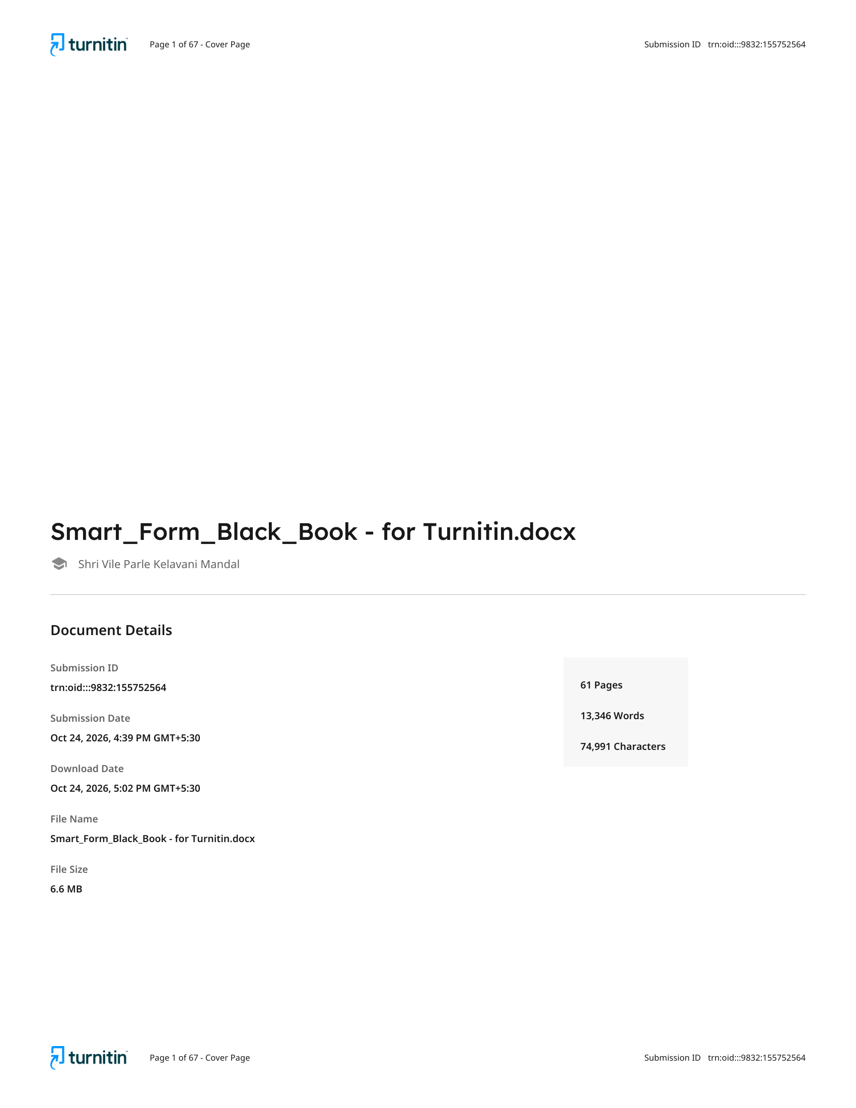
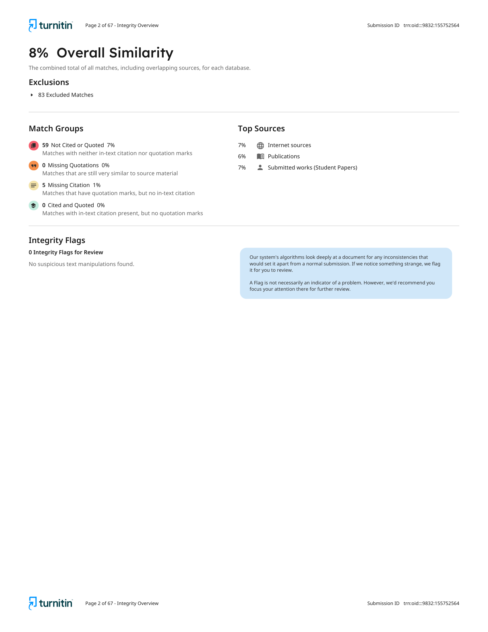
Figure E.1 Similarity report
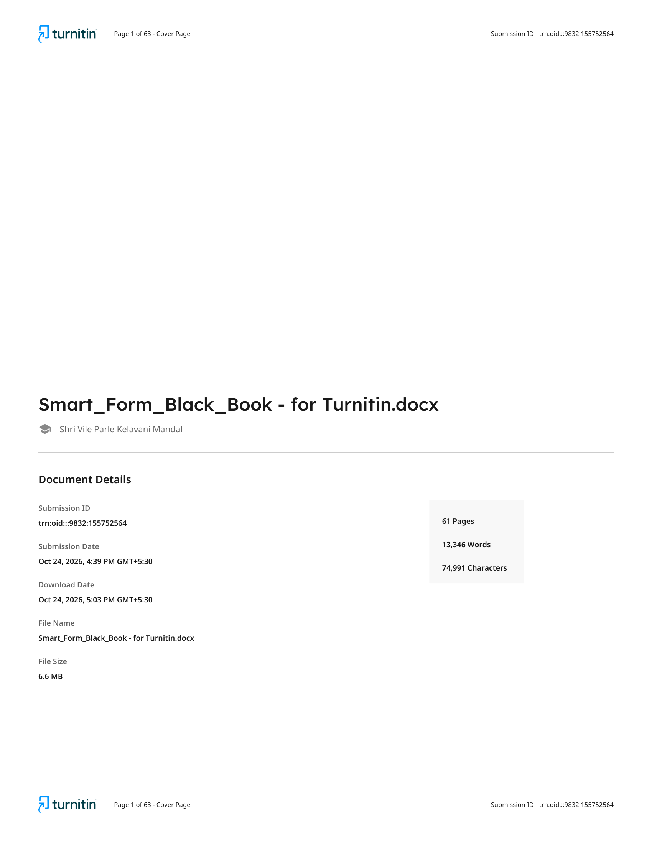
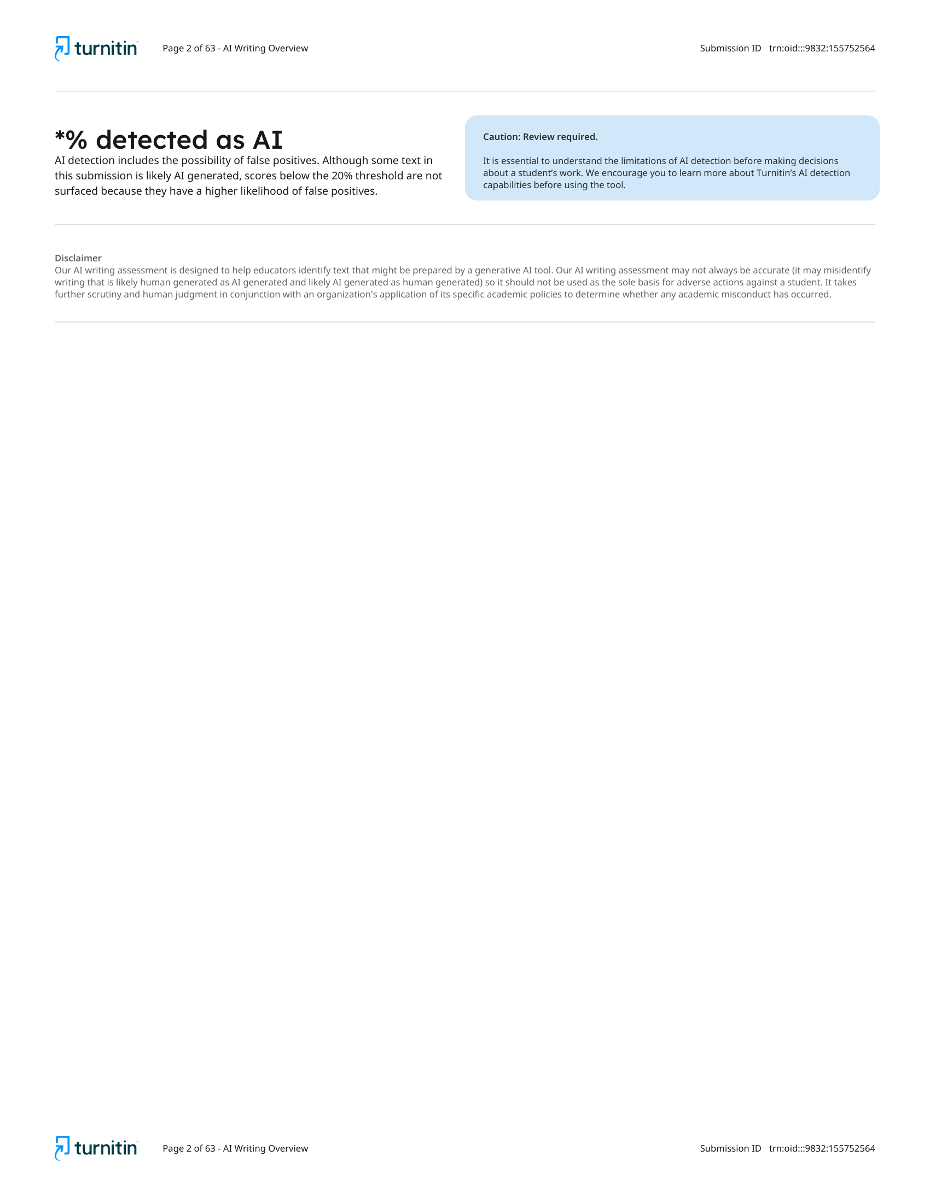
Figure E.2 AI-writing report

